
REPUBLIQUE DU CAMEROON
Paix-Travail- Patrie

REPUBLIC OF CAMEROON
Peace-Work-Fatherland



AFRICAN INSTITUTE OF COMPUTER SCIENCES - CAMEROON PAUL BIYA TECHNOLOGICAL CENTER OF EXCELLENCE
P.O. Box: 13719 Yaoundé
Tel: +237.242.729.957 Fax: 22729958
E-mail: contact@iaicameroun.com

REALIZE

Tel: (237) 620256960/654486985
Email: realize.contactus@gmail.com
Website: www.realize.cm

ACADEMIC INTERNSHIP REPORT
THEME: CONCEPTION AND REALISATION OF A DIGITAL HEALTH SUPPORT AND GENOTYPE COMPATIBILITY PLATFORM FOR SICKLE CELL PREVENTION IN CAMEROON

Internship carried out from the 1st of July to the 30th of September 2025 at the company REALIZE as part of my pursuit to obtain a
Higher Technician Diploma (HTD) in Computer Science
Option: Software Engineering
Submitted by:
METOMO JOSEPH EMMANUEL RALPH
Level II Student at AICS Cameroon

Supervisors:
Academic Supervisor:
Mr. TSEMBOM PERCY
Software Engineer at REALIZE
Mme NZALI CLAUDIA
Lecturer at AICS Cameroon

Professional Supervisor:
ACADEMIC YEAR:
2024-2025

DEDICATION

DEDICATION

THIS BOOK IS DEDICATED TO THE METOMO FAMILY

ACKNOWLEDGEMENTS

SUMMARYACKNOWLEDGEMENT

This work wouldn’t have been a success without the important contributions of a good number of people who took it upon themselves to see this work accomplished. Our sincere gratitude goes to the following:
- The Resident Representative of IAI-Cameroon, Mr. Armand Claude ABANDA, for his support, words of encouragement, and the different advice on how to approach situations.
- The chief executive officer of REALIZE, Mr. NDABOSE DANIEL, and his staff for trusting us by allowing us to serve as interns in their prestigious enterprise.
- Our professional supervisor, Mr. TSEMBOM PERCY, for his availability, advice, and moral support throughout the internship period, which led to the realization of this project.
- Our academic supervisor, Mme. NZALI CLAUDIA, for her encouragement, availability, tolerance, advice, and moral support throughout the internship period.
- To our academic teachers, Mr. AGBOR, Mr. MESSIO, and Mme TCHOUTOUO, for their assistance in the realization of this document.
- To our family members for the guidance, love, moral and financial support throughout this period.
- To all our classmates and friends near and far for their continuous support throughout the drafting of this document.

SUMMARY

SUMMARY

DEDICATION I
ACKNOWLEDGEMENTS II
SUMMARY III
LIST OF TABLES V
LIST OF FIGURES VI
GLOSSARY VIII
ABSTRACT IX
GENERAL INTRODUCTION 1
PART ONE: INSERTION PHASE 3
PART TWO: TECHNICAL PHASE 14
FILE ONE: EXISTING SYSTEM 15
FILE 2: SPECIFICATION BOOK 23
FILE 3 : THE ANALYSIS PHASE 41
FILE 4 : CONCEPTION PHASE 74
FILE 5 : REALIZATION 89
FILE 6 : FUNCTIONALITY TESTING 102
FILE 7 : USER GUIDE 109
PERSPECTIVES 119
GENERAL CONCLUSION 120
ANNEXES XII
BIBLIOGRAPHY XIII
WEBOGRAPHY XIV
VIDEOGRAPHY XV
REFERENCES XVI
TABLE OF CONTENT XVIII

LIST OF TABLES

Table 1 Hardware Resource 11
Table 2 Software Resources 11
Table 3 Limitations of the existing system 19
Table 4 Chronogram of activities 32
Table 5 Software resources for Drepalife (Source Mercurial 2024) 35
Table 6 Hardware Resources for drepalife (source: https://www.scribd.com/document/561202966/mercuriale-2024) 36
Table 7 Human resources for Drepalife (Source Mercurial 2024) 36
Table 8 Global estimation 37
Table 9 List of participants 37
Table 10 Comparative analysis between MERISE and UML 46
Table 11 Component of use case diagram 50
Table 12 Actors of our system 51
Table 13 Secondary Actors of drepadata 52
Table 14 textual description of usecase 55
Table 15 Textual description of make payment 56
Table 16 Textual description for genotype compatibility match test 57
Table 17 Components of communication diagram 60
Table 18 Components of sequence diagram 63
Table 19 Components of activity diagram 68
Table 20 Components of a class diagram 80
Table 21 Components of a state machine diagram 83
Table 22 Components of a package diagram 86
Table 23 Component of the deployment diagram 93
Table 24 Components of component diagram 96

LIST OF FIGURES

Figure 1 Realise localisation 8
Figure 2 functional branch of realize 10
Figure 3 Drepalife gantt project planning 34
Figure 4 UML Structural and behavioural diagram 45
Figure 5 2TUP diagram(Source https://www.allacronyms.com/2TUP/2TrackUnifiedProcess) 47
Figure 6: Formalism of use case diagram 49
Figure 7 General Usecase of Drepalife 53
Figure 8 specific diagram for make genotype compatibility match test 54
Figure 9 Formalism of communication diagram 59
Figure 10 Authenticate communication diagram 60
Figure 11 make genotype test match communication diagram 61
Figure 12 make payment communication diagram 61
Figure 13 Formalism of sequence diagram 62
Figure 14 Authentication sequence diagram 64
Figure 15 make payment sequence diagram 65
Figure 16 make genotype test match sequence diagram 66
Figure 17 Formalism of activity diagram 67
Figure 18 Authenticate activity diagram 70
Figure 19 make genotype test match activity diagram 71
Figure 20 make payment activity diagram 72
Figure 21 MVC architecture pattern 78
Figure 22 Formalism of a class diagram 79
Figure 23 Drepalife Class Diagram 81
Figure 24 Formalism of state machine diagram 82
Figure 25 Account state machine diagram 84
Figure 26 Formalism of package diagram 85
Figure 27 Drepalife package diagram 87
Figure 28 Formalism Deployment diagram 92
Figure 29 Drepalife Deployment diagram 94
Figure 30 Formalism of Component diagram 95
Figure 31 Drepalife Component diagram 97
Figure 32 React native logo 98
Figure 33 node js logo 98
Figure 34 mongoDB logo 99
Figure 35 Gantt Project 99
Figure 36 visual paradigm logo 99
Figure 37 postman logo 100
Figure 38 jest authentication test result 106
Figure 39 test code interface 107
Figure 40 signup screen 114
Figure 41 landing screen 114
Figure 42 login screen 115
Figure 43 Role screen 115
Figure 44 genotype test match screen 116
Figure 45 patient dashboard 116
Figure 46 Drepa chatbot screen 117

GLOSSARY

- 2TUP: Two-Track Unified Process
- AICS: African Institute of Computer Sciences
- AI: Artificial Intelligence
- API: Application Programming Interface
- IAI : Institut Africain de L’Informatique
- ICT: Information and Communication Technologies
- MERISE : Méthode d'Étude et de Réalisation Informatique pour les Systèmes d'Entreprise
- MOMO: Mobile Money
- MTN: Mobile Telecommunications Network
- OM : Orange Money
- TIC : Technologies de l'Information et de la Communication
- UI: User Interface
- UML: Unified Modeling Language

ABSTRACT

The role of Information and Communication Technologies (ICT) in fostering development remains a topic of debate. In today's information-driven world, ICTs play a decisive role in Africa's growth and are increasingly recognized as essential for progress. This project, titled “CONCEPTION AND REALISATION OF A DIGITAL HEALTH SUPPORT AND GENOTYPE COMPATIBILITY PLATFORM FOR SICKLE CELL PREVENTION IN CAMEROON,” seeks to contribute to this development by addressing one of the continent’s major health concerns. The application provides individuals, couples, and families with reliable digital tools to better understand sickle cell disease, check genotype compatibility before marriage, and access health support resources using only a smartphone or any internet-connected device. To achieve this, we used React Native for the mobile application interface, Node.js for backend development, and MongoDB for database management. These tools ensured accessibility, scalability, and a user-friendly design. This report outlines the stages involved in designing, developing, and implementing the application, highlighting its role in raising awareness, enhancing prevention, and supporting affected communities.
Keywords:
- Digital Health
- Genotype Compatibility
- Health Support Platform
- Information and Communication Technologies
- Sickle Cell Prevention

RESUME

Le rôle des Technologies de l’Information et de la Communication (TIC) dans la promotion du développement reste un sujet de débat. Dans le monde actuel, dominé par l’information, les TIC jouent un rôle décisif dans la croissance de l’Afrique et sont de plus en plus reconnues comme essentielles au progrès. Ce projet, intitulé « CONCEPTION ET REALISATION D’UNE PLATEFORME NUMERIQUE DE SUIVI DE SANTE ET DE COMPATIBILITE DE GENOTYPE POUR LA PREVENTION DE LA DREPANOCYTOSE AU CAMEROUN », vise à contribuer à ce développement en s’attaquant à l’un des principaux problèmes de santé du continent. L’application offre aux individus, aux couples et aux familles des outils numériques fiables pour mieux comprendre la drépanocytose, vérifier la compatibilité de leur génotype avant le mariage, et accéder à des ressources de suivi de santé à l’aide d’un simple smartphone ou de tout autre appareil connecté à Internet. Pour atteindre cet objectif, nous avons utilisé React Native pour l’interface mobile, Node.js pour le développement du backend et MongoDB pour la gestion de la base de données. Ces outils ont permis d’assurer l’accessibilité, la scalabilité et une conception conviviale. Ce rapport présente les étapes de conception, de développement et de mise en œuvre de l’application, tout en soulignant son rôle dans la sensibilisation, la prévention et le soutien des communautés concernées.
Mots-clés :
- Compatibilité de Génotype
- Drépanocytose
- Plateforme de Suivi de Santé
- Santé Numérique
- Technologies de l’Information et de la Communication

GENERAL INTRODUCTION

Despite various challenges, the field of computer science has continued to evolve and expand its impact. Today, individuals worldwide face numerous difficulties that require effective technological solutions tailored to their needs. Organizations increasingly depend on professionals with strong training in Information Technology and Communication to address these demands. In response to these challenges, the African Institute of Computer Sciences (AICS), a leading institution in the field, has established a three-month internship program for Level 2 students. This program is designed to bridge theoretical knowledge and practical skills by engaging students in real-world projects, enhancing their competencies while supporting organizations in overcoming obstacles and fostering growth. The selected organization for this internship was REALIZE, a software development company committed to sustainable development. The project focused on the "CONCEPTION AND REALIZATION OF A DIGITAL HEALTH SUPPORT AND GENOTYPE COMPATIBILITY PLATFORM FOR SICKLE CELL PREVENTION IN CAMEROON," which was structured into eight main phases to ensure comprehensive development and deployment.
To ease understanding, we divided this document into eight (8) parts. These are:
- Insertion Phase: Here we shall talk about our host company, their services, mission, as well as our first two weeks at our host company.
- Existing System: Here, we shall present the existing system in place, which is the one used for consultation and follow-up purposes.
- Specification Book: In this book, we specify the needs of the user, taking into consideration the time and cost of the project.
- Analysis Document: Here, we shall present the analysis method chosen, together with the presentation of all the diagrams used for the analysis of this project.
- Conception phase: This presents the generic and detailed conception of the project to bring out real-world constituents.
- The Realization phase: This phase will permit us to visualize the implementation process of the solution.
- Test of functionalities: In this phase, we shall present to you the different functionalities or modules of our application and how they work.
- The User Guide: This elaborates on all conditions necessary to use the application and how to use it.

PART ONE: INSERTION PHASE

Preamble
The inserted document forms part of my internship report, which details the structure and objectives of the organization where I completed my internship. It presents an overview of my internship environment and delineates the different stages I underwent to assimilate into the company successfully

Content:

INTRODUCTION

- WELCOMING AND INTEGRATION

- GENERAL PRESENTATION OF REALIZE

- HARDWARE AND SOFTWARE RESOURCES

- BRIEF PRESENTATION OF THE PROJECT

CONCLUSION

INTRODUCTION
Professional integration is a process that enables individuals or groups to enter the job market under conditions that enhance their chances of securing employment. During our academic internship, we had the opportunity to intern at REALIZE for three months, with the integration phase lasting two weeks. This section of the internship report outlines the structure and operations of the organization, the student's experience during the reception period, and the research topic pursued during this time.

WELCOMING AND INTEGRATION
The welcoming and integration event took place on the 1st of July at 8:15 am. Upon arrival, we were greeted by Mr. TSEMBOM PERCY, the senior developer, who delivered an inspiring welcoming speech. Having interned at REALIZE last year, this moment felt familiar, though it was refreshing to reconnect with the team. We proceeded with a presentation and a meeting focused on discussing the challenges we faced during the coding test, which was a prerequisite for our internship at the company. The meeting also included an overview of the enterprise's structure, its internal policies, and the specific workstations assigned to each intern. Given my previous experience, I was able to quickly reorient myself within the company's environment. Mr. Tanue concluded by encouraging us to strive for excellence and offered his support for any issues we might encounter.
After settling into our designated workstations, we were promptly assigned our first task for the day. During the first week, we conducted a verification of concepts using fundamental HTML and CSS to ensure everyone was on an even playing field before progressing. We then engaged in discussions about project ideas, where we were encouraged to propose our own. My previous experience made it easier to contribute and refine these ideas. Subsequently, we were tasked with researching these ideas, as the enterprise valued our initiative and did not impose any themes on us.
In the second week, we focused on JavaScript concept verification exercises to assess our understanding and reasoning skills. We held a detailed discussion with our professional supervisor about the specification book and its various components, where he outlined what was expected of us in each segment. We also continued developing our project ideas into a concrete plan, benefiting from my previous familiarity with the company's expectations and processes.

GENERAL PRESENTATION OF REALIZE

Background
Realize is a Cameroon-based non-governmental tech start-up institute founded by Mr. NDELOKAKEH Daniel in 2022, which proposes IT solutions and empowers the use of new technologies in Cameroon

Missions, Visions, and Activities of Realize

Missions:
The mission of Realize mainly relates to the empowerment and the perpetuation of Technology use. These missions include:
- Design and realize mobile-oriented software for companies and individuals;
- Assist newborn companies for quick growth using computer science;
- Provide training and certifications to improve qualified human resources in many fields of study;
Take an active part in the sustainable development of the world through innovative solutions and virtual reality.

Vision:
At Realize, we believe that the true potential of every organization and individual can be unlocked through the harmonious fusion of analysis, development, realization, and data analytics. Our vision propels us forward, guiding us to make a lasting impact on the digital landscape and shape a future where innovation knows no bounds."

Activities:
The activities of Realize range from computer science, engineering, and training. We can outline the following:
- Conception, realization, and hosting of websites;
- Software development and maintenance;
- Training in software-related fields;
- Conception and realization of multimedia;
- IT consulting and innovation
- IT support

Localization
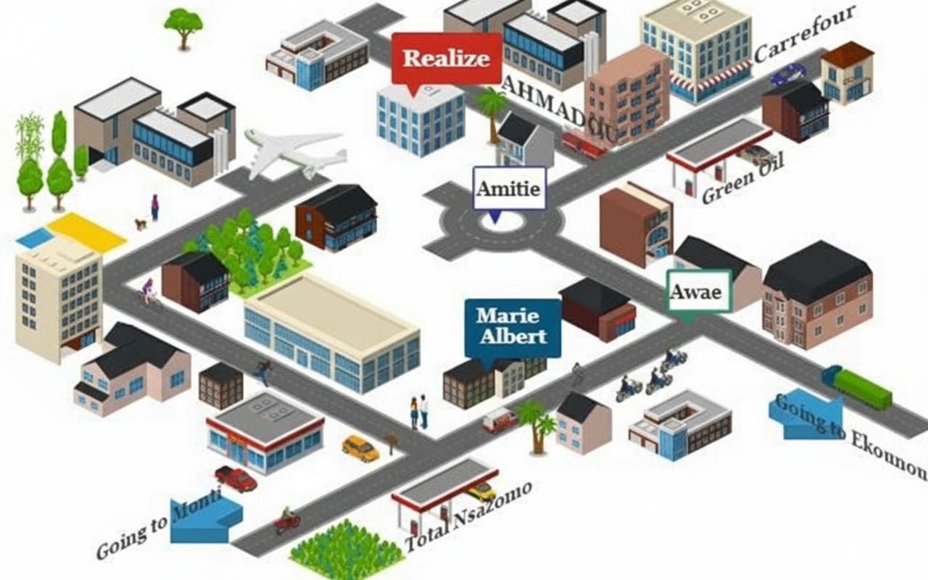
Figure 1 Realise localisation
- ORGANIZATION OF REALIZE

Administrative organization
Realize is administratively organized as follows:

The General management
This is the highest level of the company, which takes care of the following:
- Proper functioning of each department.
- Define project strategies.
- Provide leadership and guidance to the company’s employees.
- Makes critical decisions that could affect the company’s operations or reputation
- Severe as a point of contact for key stakeholders such as investors, etc.

Human resource department
This department is in charge of the following:
- Recruitment and Hiring
- Acts as a liaison between employees and management;
- Manages employee compensation and benefits programs;
- Develops and implements company policies and procedures, ensuring compliance with employment laws and regulations.
- Manages administrative tasks related to employee records, data management, and HR systems

Communication Department
This department is in charge of the following:
- Handles public relations activities, which involve managing the company’s reputation and image;
- Responsible for crafting and delivering messages to external stakeholders such as customers etc.;
- It fosters effective communication within the company;
- They create and manages content across different platforms and channels;

Department of Financial Affairs
This department is in charge of the following:
- Responsible for developing and managing the company’s financial plans and budgets;
- Prepare and presents accurate and timely financial reports to management, stakeholders, and regulatory authorities;
- Responsible for managing cost and expenses within the organization;
- Ensures compliance with tax laws and regulations. Etc.

Technical department
This department is in charge of the following:
- Responsible for managing the company’s technological infrastructure, including networks, hardware;
- Play a role in managing and maintaining the company’s data;
- Responsible for implementing and maintaining cybersecurity measures to protect the company’s digital assets from potential threats;
- Interacts with technology vendors and manages relationships with external service providers. Etc.

Software Engineering Department
This department is in charge of the following:
- Primarily responsible for developing software applications and systems;
- Responsible for maintaining and supporting software applications throughout their lifecycle;
- Evaluation and realization of projects, etc.

FUNCTIONAL ORGANIZATION OF REALIZE
The functional branch of Realize is organized as follows

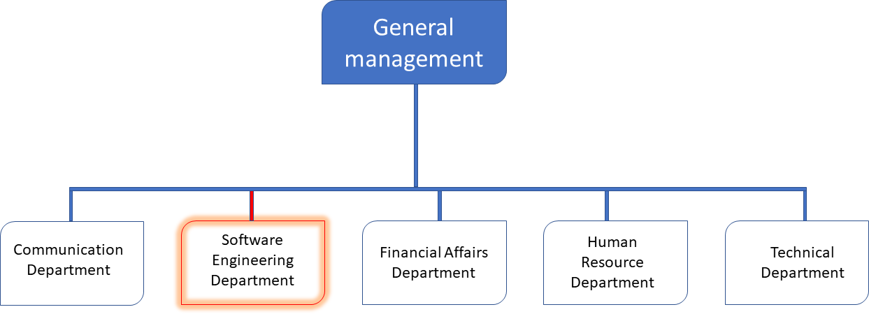
Figure 2 functional branch of realize

HARDWARE AND SOFTWARE RESOURCES

HARDWARE RESOURCES
Table 1 Hardware Resource
No | DESIGNATION | QUANTITY | CHARECTERISTICS | OBSERVATION
1 | MacBook Pro | 1 | APPLE | Good
2 | Modem | 1 | CAMTEL | Good
3 | LCD Screen | 1 | HP | Excellent
4 | Training  Equipment and office furniture | / | / | /

SOFTWARE RESOURCES
Table 2 Software Resources
DESIGNATION | SOFTWARE
Operating System | Windows 10, Mac OS, Parrot Linux
Design tools | Photoshop
Integrated development environment (IDE) | Visual Studio Code
Text editor | Sublime text, notepad++
Database management system (DBMS) | MongoDB, PostgreSQL, MySQL
Web browser | Google chrome, Microsoft edge
Document editor | Microsoft Office Word
Presentation | Microsoft Office PowerPoint

- BRIEF PRESENTATION OF PROJECT
At the end of the initial two-week orientation period of my internship at Realize, we were assigned the project titled "CONCEPTION AND REALISATION OF A DIGITAL HEALTH SUPPORT AND GENOTYPE COMPATIBILITY PLATFORM FOR SICKLE CELL PREVENTION IN CAMEROON." This project involves developing a comprehensive healthcare mobile application designed to support sickle cell patients and their families. The platform empowers users with tools for health management, crisis guidance, and genotype compatibility analysis to assess the risk of having a child affected by sickle cell disease. The application aims to simplify the understanding and management of sickle cell risks. Its primary objective is to provide an accessible, user-friendly, and reliable tool for families in Cameroon, ultimately contributing to reducing the prevalence of the disease through informed decision-making and early prevention.

CONCLUSION
Our insertion phase at REALIZE lasted for two weeks. During this time, we discovered the remarkable environment we were in, which encourages hard work, perseverance, and collaboration; qualities that many students seek. We learned about the company's missions and activities, and we had the opportunity to meet and connect with the staff and other interns at REALIZE. As a culmination of this phase, we were assigned the theme “CONCEPTION AND REALISATION OF A DIGITAL HEALTH SUPPORT AND GENOTYPE COMPATIBILITY PLATFORM FOR SICKLE CELL PREVENTION IN CAMEROON
”

PART TWO: TECHNICAL PHASE

FILE ONE: EXISTING SYSTEM

Preamble
This chapter will present and elucidate our central theme, which is the primary emphasis and objective of our project. We shall also expound on the predicament that prompted us to devise our proposed solution, and detail the characteristics and operations of the software we have planned to construct.

Content:

INTRODUCTION
- PRESENTATION OF THE THEME
- STUDY OF THE EXISTING SYSTEM
- LIMITATIONS OF THE EXISTING SYSTEM
- PROBLEMATIC
- PROPOSED SOLUTIONS
CONCLUSION

INTRODUCTION
In this part of our report, we will clearly explain our theme to provide a solid understanding of the subject. We will also take time to study the current system in detail and carefully identify both its strengths and weaknesses. This analysis will help us highlight what is working well and what still needs improvement. Based on the findings, we will then present the problem statement, which represents the main challenge or gap that the current system faces. By clearly stating the problem, we can demonstrate why a new approach is necessary. Ultimately, we will propose a well-considered solution that directly addresses this issue and enhances the system's overall performance.

PRESENTATION OF THE THEME
The theme of this project is the CONCEPTION AND REALISATION OF A DIGITAL HEALTH SUPPORT AND GENOTYPE COMPATIBILITY PLATFORM FOR SICKLE CELL PREVENTION IN CAMEROON, developed during an internship at Realize. This mobile application aims to empower families affected by sickle cell disease by providing an accessible platform that supports health management and offers genotype compatibility analysis to assess the risk of having a child with sickle cell disease. The app simplifies risk assessment by enabling parents to input genotype information and receive clear, accurate predictions regarding their child’s sickle cell risk. It caters to diverse user needs by offering both detailed genetic risk evaluations and straightforward educational guidance to support informed family planning in Cameroon.
Healthcare providers can integrate their services within the platform, offering genotype testing and genetic counseling tailored to local contexts. This integration allows providers to expand their reach while enabling families to select the appropriate level of healthcare support. To ensure reliability and trust, the app includes a verification process for healthcare providers, guaranteeing that only accredited and trustworthy professionals are available to users. The system design follows rigorous methodologies, including UML and the 2TUP process, ensuring a secure, user-friendly, and robust platform that contributes to reducing the prevalence of sickle cell disease in Cameroon

STUDY OF THE EXISTING SYSTEM
In the current system in Cameroon, assessments of sickle cell risk and genotype compatibility are mostly informal and fragmented. Families often rely on community knowledge, personal networks, or incomplete information sources to evaluate their risk, which leads to confusion and poor decision-making. While some health facilities provide individual genotype testing, they rarely offer structured compatibility assessments for couples. This creates a gap between diagnosis and practical decision-support for family planning.
Couples who want to understand their genetic compatibility face significant barriers. There are no centralized digital tools that allow them to input their genotypes and instantly receive a compatibility assessment, clear explanations of the risks for potential children, or tailored guidance on next steps. Instead, many must manually seek consultations, interpret results on their own, or depend on word-of-mouth information. This process is not only time-consuming but also prone to misinformation.
In addition, the current system lacks transparency and accessibility. Few healthcare providers offer clear, verified, and easily accessible online resources. Families, therefore, struggle to identify trustworthy counseling services, and educational materials explaining genotype compatibility remain limited. The result is a fragmented and inequitable landscape, especially for those outside urban centers.
This situation highlights the urgent need for a unified, accessible, and user-friendly digital platform. The mobile application developed in this project responds to that need by providing a genotype match assessment module, an AI-powered health support bot for instant counseling and information, and access to verified educational resources on sickle cell prevention. The platform also integrates features that connect users with healthcare providers for follow-up, ensuring that couples and families are supported not only with compatibility results but also with continuous health guidance. Built using UML for structured system modeling and the 2TUP process for development, the platform aims to reduce misinformation, increase awareness, and empower families with reliable tools to make informed reproductive and health-related decisions.

LIMITATIONS OF THE EXISTING SYSTEM
Table 3 Limitations of the existing system
LIMITATIONS | CONSEQUENCES | PROPOSED SOLUTION
 | Families underestimate risks, make uninformed marriage or reproductive choices | Provide educational resources and an AI-powered health bot for instant guidance
  Low public awareness about sickle cell disease and genotype compatibility
No centralized system for genotype compatibility checks | Couples face confusion, delays, and a higher chance of unplanned sickle cell births | Offer a unified digital platform with an automated genotype match test for quick, accurate results
Lack of clear, accessible, and standardized information on genetic risks | Families misinterpret their genotypes, leading to uncertainty and anxiety | Integrate a user-friendly compatibility calculator with clear explanations and prevention advice
Limited availability and visibility of professional healthcare and counseling services | Many families cannot find reliable support, especially in rural areas | Connect users to verified healthcare providers within the app
Stigma and misinformation in communities | Families may hide their genotype, rely on false beliefs, or delay action | Spread verified knowledge, share real-life guidance, and encourage open, stigma-free discussion
Fragmented and manual process to access services | Families waste time searching or relying on unreliable sources without standardized support | Centralize access by integrating healthcare contacts, provider verification, and educational resources in one app

PROBLEMATIC
In Cameroon, limited awareness about sickle cell disease, delayed genotype testing, and the absence of accessible educational resources contribute to uninformed decisions and high early mortality rates. These issues lead us to the key question: HOW CAN WE PREVENT EARLY MORTALITY FROM SICKLE CELL THROUGH BETTER AWARENESS AND INFORMED DECISIONS IN CAMEROON?

PROPOSED SOLUTION
To address the identified challenges, we propose developing a comprehensive mobile health support and genotype compatibility match system during our internship at Realize. This platform, built using technologies such as MongoDB, React Native, and Node.js, and designed following UML and the 2TUP Process, offers a centralized solution for assessing and managing sickle cell risks. It aims to significantly improve efficiency, transparency, and user experience for families in Cameroon.
- Accessible Risk Information: Families can check sickle cell risk easily through genotype compatibility tools and simplified explanations, helping them understand potential outcomes for their children.
- Awareness and Education: The app provides clear, easy-to-read resources about sickle cell disease, its risks, and preventive measures, empowering families with knowledge that is often missing in communities.
- Varied Service Options: The system provides detailed genotype compatibility analysis, educational resources, and access to genotype testing and genetic counseling, meeting the diverse needs of families from in-depth medical insights to basic guidance.
- Transparent Information and Reviews: Verified healthcare providers list their services on the platform, supported by educational content and user feedback to ensure reliability and trust.
- Trust and Reliability: Only accredited clinics and trusted medical professionals are highlighted in the app, ensuring families can rely on the information and services they find.

CONCLUSION
The project theme plays a crucial role in defining the scope and identifying the healthcare system for sickle cell risk assessment in Cameroon. Conducting a thorough analysis of the current system during an internship at Realize was essential to understand its limitations, such as lack of organization and limited access to healthcare services. By leveraging information technology and the 2TUP Process alongside UML, we framed the problematic of simplifying sickle cell risk assessment for families and offered a well-formulated solution through Drepalife. This platform tackles the identified issues, empowering parents with accessible, transparent, and reliable tools to predict sickle cell risks for their child, fostering informed healthcare decisions.

FILE 2: SPECIFICATION BOOK

Preamble
The specification book serves as a contractual document before the application development process commences. It succinctly outlines the expectations of the project owner and the respective responsibilities of all parties involved. It provides a specific and detailed description of the topic and user requirements, as well as the necessary conditions for project execution. The project's success will depend on careful allocation and management of the various resources available, including physical, financial, and human assets. Therefore, this document outlines the criteria that the developer must adhere to ensure the success of the project.
Content:

INTRODUCTION
- CONTEXT AND JUSTIFICATION
- OBJECTIVES OF THE PROJECT
- EXPRESSION OF NEEDS
- PROJECT PLANNING
- ESTIMATED COST OF THE PROJECT
- LIST OF PARTICIPANTS
- PROJECT CONSTRAINTS
- DELIVERABLES.
CONCLUSION

INTRODUCTION
The report's specification book enables us to provide comprehensive details about our topic, enhancing our understanding and improving its chances of success. To establish the project's scope, we will describe the context of our topic and identify the issues within it that we aim to solve. Once the solution is proposed, we will outline the objectives we have set for ourselves and for the project. Also, we will assess the functional and non-functional requirements of our system before designing a plan to ensure the timely completion of the project and determine the financial resources needed. Subsequently, we will outline the expected project deliverables at the conclusion of the project.

CONTEXT AND JUSTIFICATION

Context
Sickle cell disease remains a major health challenge in Cameroon, where low awareness, fragmented healthcare services, and stigma hinder effective prevention. Couples often lack reliable access to information on genotype compatibility, leading to uninformed marital choices and an increased risk of having affected children. Existing methods of assessing compatibility are informal, inconsistent, and largely inaccessible, forcing families to depend on incomplete information or irregular counseling services.

Justification
To address these challenges, this project introduces Drepalife, which provides accurate risk assessments, educational resources, counseling tools, and access to verified healthcare providers. By offering a user-friendly and accessible solution, the platform empowers individuals and families to make informed decisions, improve prevention, and reduce the social and medical impact of sickle cell disease in Cameroon
DrepaLife addresses these challenges by creating a simple, accessible, and trustworthy digital health platform that:
- Improves Access: Enables families to check genotype compatibility risks and connect with nearby verified healthcare providers through an intuitive mobile interface.
- Raises Awareness: Delivers clear and culturally adapted educational resources on genotype compatibility, sickle cell prevention strategies, and practical daily health guidance.
- Supports Families’ Needs: Offers flexible tools ranging from quick compatibility checks to comprehensive educational content, tailored to users with varying levels of health literacy.
- Builds Trust: Features only verified healthcare providers and accredited information sources, ensuring credibility and user confidence.
By aligning with the rapid growth of mobile health solutions in Africa, DrepaLife empowers families with the knowledge, resources, and tools needed to prevent new sickle cell cases, encourage early diagnosis, and significantly improve long-term disease management in Cameroon.

OBJECTIVES OF THE PROJECT

GENERAL OBJECTIVE
The main objective is to improve healthcare access and management for sickle cell patients by connecting them with qualified medical professionals, providing reliable health tips, and offering essential tools such as crisis management guides and genotype compatibility checks
- SPECIFIC OBJECTIVES
- Facilitate Easy Access to Medical Information
Provide users with reliable educational resources on sickle cell disease and genotype compatibility through the app.
- Enhance User Experience
Design a simple, intuitive, and user-friendly interface for smooth navigation and accessibility.
- Ensure Transparency in Medical Consultations
Connect users with verified healthcare providers and present clear, trustworthy consultation details.
- Improve Accuracy of Genotype Compatibility Checks
Provide automated and reliable compatibility assessments with clear explanations of potential risks.
- Join Community
Create a safe digital space where users can connect, share experiences, and support each other.
- Request Consultation
Enable users to book or request online/offline consultations with healthcare professionals directly via the platform.
- AI Chat Bot Integration
Provide instant, 24/7 assistance for answering common questions, guiding users, and offering preliminary health advice.
The project is characterized by the following:
                - Project Name: Drepalife
                - Project Target: Individuals living with sickle cell disease, families seeking genotype compatibility information, and health professionals managing sickle cell patients.
                - Technical Specification: Mobile application (React Native) integrated with a backend (Node.js, MongoDB) for real-time data management, secure authentication, genotype compatibility analysis, and online payment processing for consultations.

EXPRESSION OF NEEDS

Functional Needs
In this context, functional requirements describe what the system or application should do. The modules are as follows;
Patient:
- Create Account: Patients can register and fill in personal and medical information relevant to sickle cell management (e.g., genotype).
- Submit Daily Health Status: Patients regularly submit updates on their current health condition.
- Perform Crisis Self-Help Procedure: Patients can follow guided steps for managing a sickle cell crisis on their own.
- Request Genotype Compatibility Test: Patients can request an analysis of genotype compatibility for family planning.
- Request Expert Consultation: Patients can request medical consultations with health experts through the app.
- Make Secure Payment for Consultation: Patients make secure payments for premium consultation services through integrated payment APIs.
- Chat with an AI chatbot: Patient can chat with a well-trained medical chatbot
- Rate Health Expert: Patients provide feedback and rate the health expert after consultations.
Health Expert / Medical Doctor:
- Set Profile: Health experts create and update their professional profiles, including qualifications and specialties.
- Respond to Consultation Requests: Experts review and respond to patient consultation requests.
- Provide Recommendations: Health experts offer personalized health advice and crisis management guidance.
- Track Patient's Health Progress: Experts monitor and track ongoing health data submitted by patients.
- Update Crisis Management Protocol: Experts update and validate protocols and educational content related to crisis care.
- Publish and Update Health Tips: Admins manage the publication of daily health tips and educational content.
Administrator:
- Register and Approve Health Experts: Admins verify and approve health expert accounts and credentials.
- Manage User Accounts: Admins oversee the registration and management of all users, including patients and experts.
- Validate Crisis Management Content: Admins review and approve updated crisis management protocols and health tips.

Non-Functional Needs
In this section, non-functional requirements define the quality attributes, standards, and performance measures that the system must adhere to. These aspects ensure the overall performance, security, and usability of the application.
  - Performance Requirements
- Handle Concurrent User Actions: The system must support multiple patients submitting health statuses, requesting consultations, or performing genotype compatibility tests simultaneously without lag, especially during peak usage times.
- Fast Response Times: Actions such as submitting health status, receiving compatibility results, or initiating a consultation must be completed in under 3 seconds for a seamless user experience.
2. Security Requirements
- Data Encryption: Encrypt all sensitive data, including health profiles, payment details, and genotype data, to protect user actions like submitting health status or requesting genotype tests.
3. Scalability Requirements
- Support Growing User Actions: The system must scale to handle increasing numbers of patients submitting daily health statuses, requesting consultations, or performing genotype tests without performance degradation.
- Horizontal Scaling: Enable horizontal scaling for both frontend (e.g., patient app interface) and backend (e.g., genotype analysis service, consultation processing) to support growing demand for actions like health status updates and expert responses.

PROJECT PLANNING

Chronogram of activities
We began our internship on the 1st of July, till the 30th of September 2025, a total of 3 months. To this, it was an obligation for us to manage our time properly so as to finish on time. This section presents how the work phases were scheduled throughout my internship period.
Table 4 Chronogram of activities
PHASE | OBJECTIVE | OUTPUT | DURATION | PERIOD
INSERTION | Collection of  information on the enterprise | Insertion book | 2 weeks | 08th July to 19th July
EXISTING SYSTEM | Study of the existing  System | Existing  System | 1 week | 22nd July to  26th July
SPECIFICATION BOOK | Specification of the user needs | Specification Book | 1 week | 29th July to 02nd August
ANALYSIS | Capture of needs Use case and textual  description Modelling | Analysis Book | 2 weeks | 05th August to 16th August
CONCEPTION | Preliminary conception  and Detailed conception | Conception  book | 2 weeks | 19th August to  30th August
REALIZATION | Implementation Unitary test Integration Test Development | Realization book | 3 weeks | 02nd  September to 20th  September
TEST OF FUNCTIONALITIES | Testing of the software and debugging | Test of functionalities | 1 week | 23rd September to 27th  September
INSTALLATION AND  USER GUIDE | Documenting software | User Guide | 1 week | 30th September  to 04th October

Gantt Project planning
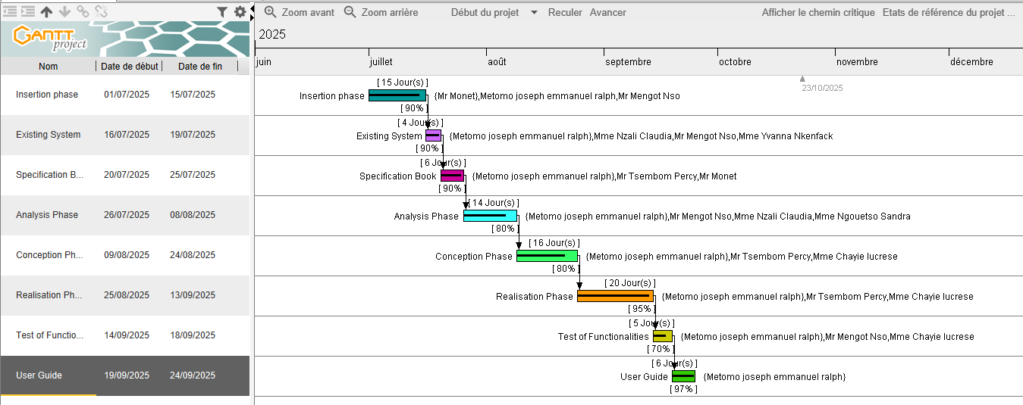
Figure 3 Drepalife gantt project planning

ESTIMATED COST OF THE PROJECT

Software Resources
For the realization of this project, we will need the following software applications:
Table 5 Software resources for Drepalife (Source Mercurial 2024)
RESOURCES | DESIGNATION | USAGE | QUANTITY | UNIT COST  (FCFA)
Formatting | MICROSOFT OFFICE PROFESSIONAL  2019 | Writing of the report | 1 | 355465
Mobile Testing | Expo Go (Mobile Device) | Testing React Native-based mobile app features | 1 | Freeware
Code Editor | Visual Studio  Code | For writing the code  of the application | 1 | Freemium
Project  Planning | Gannt Project | For building a Gantt  chart | 1 | Freemium
UML  Analysis | Visual Paradigm | Drawing UML diagrams to map the action | 1 | Community Version
Version Control | Git & GitHub | For tracking and  managing changes to software code | 1 | Free Version
TOTAL 1 |  |  | 6 | 355465

Hardware Resources
This includes the material resources used to realize this project. The table below shows a representation of these different materials:
Table 6 Hardware Resources for drepalife (source: https://www.scribd.com/document/561202966/mercuriale-2024)
RESOURCES | HARDWARE | QUANTITY | UNIT COST (FCFA)
Computer | Lenovo Desktop-Q1U5165 (Intel Core i7-5600U, 8GB RAM, 256GB SSD) | 1 | 100,000
Network | Local network installation | 1 | 226,000
Removable Disk | USB HP 2.2 FLASH DRIVE  V225W - 8 GB | 1 | 4,160
Smartphone | Google Pixel 6 (256GB) | 1 | 110,000
Total 2 |  | 4 | 440,160

Human resources
Table 7 Human resources for Drepalife (Source Mercurial 2024)
ROLE | NUMBER OF  DAYS | QUANTITY | COST PER  DAY | TOTAL PRICE  (FCFA)
Project Manager | 90 | 01 | 30 000 | 2 700 000
Analyst | 21 | 01 | 25 000 | 525 000
UI/UX Designer | 30 | 01 | 10 000 | 140 000
Programmer | 30 | 01 | 15 000 | 450 000
Tester | 14 | 02 | 10 000 | 140 000
TOTAL 3 |  |  |  | 3 955 000

Global Estimation
Table 8 Global estimation
TOTAL 1 (FCFA) | TOTAL 2 (FCFA) | TOTAL 3 (FCFA) | Hosting Cost (Vercel) | Unexpected charges (10%) | OVERALL TOTAL  (FCFA)
355465 | 440,160 | 3,955,000 | 133,989 | 475,063 | 5,359,677
Five million, three hundred fifty-nine thousand, six hundred seventy-seven

LIST OF PARTICIPANTS
The table below presents the different persons who took part in the accomplishment of this project. They include:
Table 9 List of participants
NAME | FUNCTION | ROLE
Mr. TSEMBOM PERCY | Follows up with interns at the  company level | Professional Supervisor
Mrs. NZALI CLAUDIA | Follows up with the student at the  academic level | Academic Supervisor
Mrs. NGOUETSO SANDRA | Follows up with interns at the  company level | Software Engineer
Mrs. CHAYIE LUCRESE | Follows up with interns at the  company level | Software Engineer
Mr. MENGOT NSO | Follows up with interns at the  company level | Software Engineer
METOMO JOSEPH EMMANUEL RALPH | AICS Student Intern | Student at AICS

PROJECT CONSTRAINTS
- Software constraints
- Compatibility: The platform must be compatible with different devices (smartphones, tablets) to reach a wide audience.
- Security: Robust security measures must be put in place to protect users’ personal data and prevent any breach of confidentiality.
- User-friendliness: The user interface must be user-friendly to ensure a positive user experience.
- Material constraints
- Internet availability: The platform assumes that users have access to the Internet. However, efforts must be made to guarantee an acceptable experience even with limited Internet connections.
- Hardware compatibility: The platform must be designed to run on a variety of devices, taking into account differences in screen size and processing power.
- Quality constraints
- Accuracy of information: Guides and information provided must be accurate, up-to date and verified, to avoid giving incorrect information to users.
- Performance: The platform must be fast and responsive to avoid excessive loading times and maintain user engagement.
- Accessibility: The platform must be designed to be accessible to people with disabilities, in accordance with web accessibility standards.
- Time constraints
- Deadlines: The project must be completed within the specified deadlines to meet user needs and stakeholder expectations.
- Regular updates: Future updates and enhancements to the platform must be planned to meet the changing needs of citizens and to maintain long-term relevance.

DELIVERABLES
In this section, we will present the different elements that will be delivered at the end of this project. They include:
- Installation and user guide
- Software Application
- PowerPoint presentation

CONCLUSION
To conclude, the specification book has permitted us to present the general and specific objectives of the project, the project constraints, the functional and nonfunctional needs of the project, lay out the different resources of the project, and finally, the project planning. The end of this document will enable us to easily dive into drafting the analysis document, which will bring out the technical aspects of the project as a whole.

FILE 3 : THE ANALYSIS PHASE

Preamble
The analysis document that adheres to the specifications provides a comprehensive overview of the issue and the proposed solution, supported by diagrams. It outlines the selected analysis method for the project and explains the rationale behind this choice. All of these elements contribute to a clearer understanding of the information system being modeled.
Content:

INTRODUCTION
- METHODOLOGY
- COMPARATIVE STUDY BETWEEN MERISE AND UML
- PRESENTATION OF THE 2TUP
- CHARACTERISTICS OF THE 2TUP
- JUSTIFICATION OF THE CHOICE OF THE ANALYSIS
- MODELING
- USE CASE DIAGRAM
- COMMUNICATION DIAGRAM
- SEQUENCE DIAGRAM
- ACTIVITY DIAGRAM
CONCLUSION

INTRODUCTION
System development can be thought of as having two major components: System analysis and system design, which both help in understanding the details of the existing system or the system to be designed. The analysis and design of information systems has the vocation to allow the creation of databases, which must represent as closely as possible the reality of the field studied, thus requiring the use of a design method. This is why our choice will be directed to the UML method as it offers much to developers seeking a user-centered approach and/or a wide scope in design. This part of the report consists of the comparative study of UML and MERISE, unified processes, and finally the various diagrams that meet the functional need requirements.

METHODOLOGY
Analysis is the fundamental step in the conception of software. It is the basis for the realization of every information system. An information system is an organization of resources (human, software, and hardware), data, and feedback to attain a specific objective. Several methods and languages have been put in place to facilitate the analysis and conception of information systems, which principally have UML and MERISE.

COMPARATIVE ANALYSIS BETWEEN MERISE AND UML
- MERISE
MERISE stands for “Méthode d’Etude et de Réalisation Informatique pour des Systèmes d’Entreprise”. Although it is prescriptive to some extent, MERISE permits the participation of end users and senior management as well as data processing professionals in its decision cycle. MERISE is a method for designing, developing and carrying out IT projects. The goal of this method is to achieve the design of an information system. The MERISE method is based on the separation of data and processing to be carried out in several conceptual and physical models. The essentials of the approach lie in its three cycles: the decision cycle, the life cycle and the abstraction cycle, which cover data and process elements equally. The separation of data and processing ensures longevity in model. Indeed, the arrangement of data does not have to be often overhauled, while treatments are more frequently.
- UML
UML (Unified Modelling Language) is a standard notation for the modelling of real-world objects as a first step in developing an object-oriented design methodology. Its notation is derived from and unifies the notations of three object-oriented design and analysis methodologies: Grady Booch's methodology for describing a set of objects and their relationships, James Rumbaugh's Object-Modelling Technique (OMT), Ivar Jacobson's approach which includes a use case methodology. Other ideas also contributed to UML, which was the result of a work effort by Booch, Rumbaugh, Jacobson, and others to combine their ideas, working under the sponsorship of Rational Software. UML captures information about the static and dynamic view of a system. UML 2.5 comprises of 14 diagrams which represent the different views of a system. The 14 diagrams can be subdivided into two, Static or structural and Dynamic diagrams. These diagrams include;

- STATIC OR STRUCTURAL DIAGRAMS
- Class diagram;
- Object diagram;
- Component diagram;
- Deployment diagram;
- Composite Structure diagram;
- Package diagram;
- Profile Diagram;
- BEHAVIOURAL OR DYNAMIC DIAGRAMS
- Use case diagrams;
- Activity diagram;
- State machine diagram;
- Sequence diagram;
- Communication diagram;
- Global Interaction diagram;
- Timing Diagram;
These diagrams can be represented on the diagram bellow:
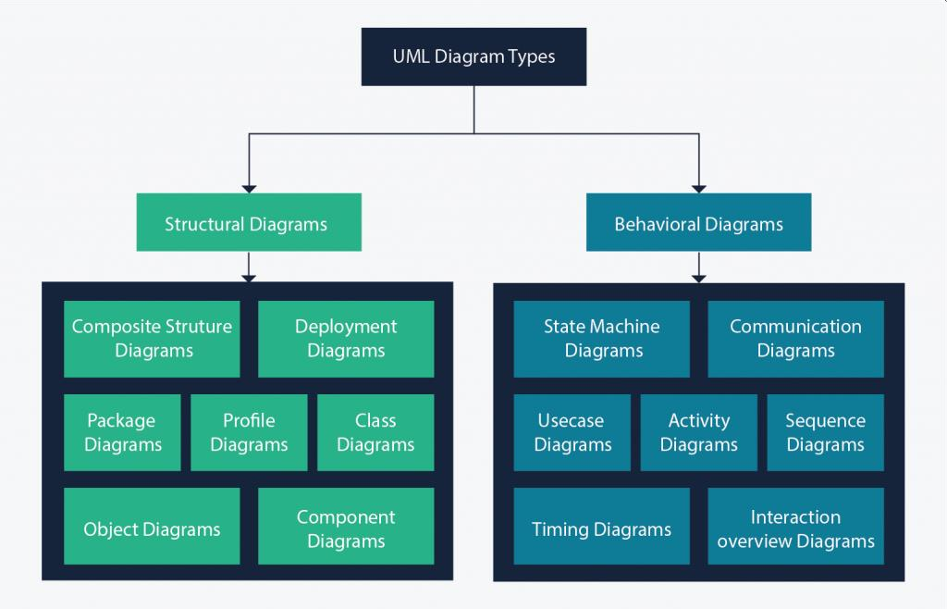
Figure 4 UML Structural and behavioural diagram
Source: https://images.edrawsoft.com/articles/what-is-uml/uml-diagram-types.png
Table 10 Comparative analysis between MERISE and UML
MERISE | UML
Méthode d’Etude et de Realization Informatique pour les Systèmes d’Entreprise | Unified Modeling Language
Merise is a method of analysis. | UML is a modeling language
Merise is a systematic method of analysis and design for information systems, i.e., it uses a system approach. | UML is, however, not a method but rather an object-oriented language that uses the 2TUP approach to model a system
It is based on a procedural approach | Based on the object approach
Merise proposes to consider the real system from two points of view:  • The Static view(data)  • The Dynamic view(treatments). Which means in Merise, we have a separate study of data and treatments | UML offers a different approach from that of MERISE in that it combines data and process

PRESENTATION OF THE 2TUP
2-TUP (Two Track Unified Process) is Y in shape and is a unified process that has as its objective to bring a solution to constraints of functional changes imposed on information systems. It proposes a development cycle that separates the functional aspects from the technical aspects. 2-TUP therefore distinguishes two main branches:
(The functional and technical branch) whose different results are being merged to realize our system.
Any unified process UP (Unified Process) process meets the following characteristics:
- It is iterative and incremental.
Some of the advantages of the 2TUP include:
- It allows the addition of modules.
- It allows flexibility in the analysis of a project.
- It is easy to design and understand.
- It allows to have a preliminary view
Below is the representation of 2-TUP:

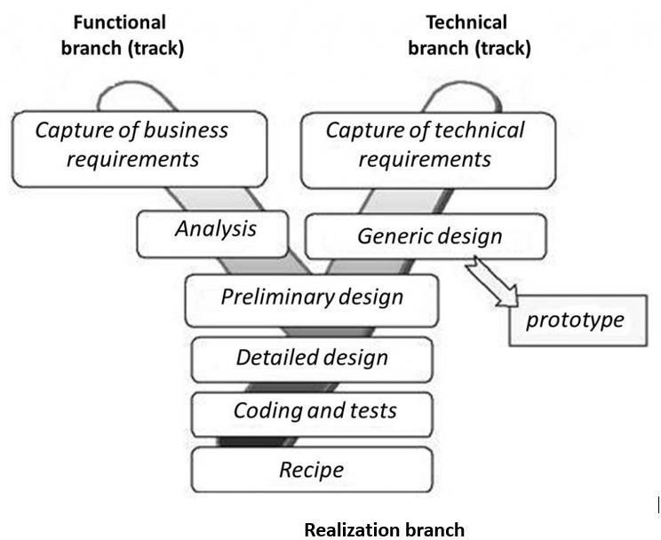
Figure 5 2TUP diagram(Source https://www.allacronyms.com/2TUP/2TrackUnifiedProcess)
- The Functional Branch:
This branch captures business needs, resulting in a model focused on the end-user’s requirements.
- The Technical Branch:
This branch proposes a generic design from the technical needs, identifies the materials, tools, and technologies to be used.
- The Implementation:
The implementation phase consists of bringing the two branches together, providing the application design, and finally the delivery of a solution adapted to the needs.
- Functional Branch (left branch)
- Capture of Business Needs: This part minimizes the risk of producing an inadequate system with the needs of users and also verifies its consistency.
- Analysis: This is the study of the specifications to find out what the system will be made of in terms of the business rules. We have the following diagrams: Use Case, Activity Diagram, State Machine Diagram, and Communication Diagram.

- Technical Branch
- Capture of Technical Needs: This stage consists of the identification of tools, materials, and technologies to use in developing the system. This technical architecture will be presented in this stage.
- Generic Designs: The technical architecture will be presented in this stage. We have the following diagram: mockUp7 Design.
- Implementation Branch (middle branch):
- Preliminary Branch: This is the stage where the analysis model is integrated into the technical architecture. The goal here is to know what technical component will be used depending on the features of the analysis. We have the following diagrams: interaction overview, Component, Deployment, package diagram and Composite Diagram.
- Detailed Design: this is the detailed design of each feature of the system. We have the following diagrams: class, object, sequence and timing Diagrams.
- Coding and Testing: This is the programming phase of the designed features, alongside testing of the coded features.
- Recipe (Result): This is the validation phase of the functions of the system developed.

CHARACTERISTICS OF 2TUP
The two-track unified process was built to be used with the Unified Modeling Language to become a method and has the following characteristics:
- It is user oriented: 2TUP is built from user’s expectation
- It is component-oriented: it offers flexibility to the model by supporting the re-use of components.
- It is an iterative process: processes are being done in iterations, and each iteration shows a precise level of abstraction.
- It is an incremental process: allowing a better functional and technical risk management and thus constituting the deadlines and the cost control.

JUSTIFICATION OF THE CHOICE OF THE ANALYSIS
Our choice was based on the modeling language UML, associated with it 2TUP, due to certain criteria, which are as follows:
- UML is based on an object-oriented approach;
- UML associate’s data and treats it;
- It is a modeling language that focuses mainly on users’ needs and expectations;
- 2TUP is a process built from an object-oriented approach and is built from UML.
- 2TUP facilitates the modeling of complex systems, which can further be readjusted.

MODELLING

USECASE DIAGRAM

DEFINITION
The use case diagram simply shows the relationship between the actors of the system and the system. It permits users to easily visualize the different actions that can be done by the users. It also clearly defines the boundaries of the system.

FORMALISM
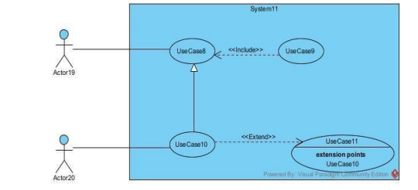
Figure 6: Formalism of use case diagram

COMPONENTS OF USE CASE DIAGRAM
Table 11 Component of use case diagram
Element | Notation | Description
Actors |  | Represents an entity that directly interacts with the system. The actor is what performs the different  possible actions of the system
Use case | 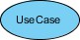 | A use case represents a functionality of the system. It is an action that can be performed by an  actor.
Association | 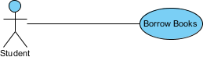 | it indicates that an actor takes part in a use Case
Include |  | An inclusion denotes that an included action must be performed before the including action can be  performed.
Extend | 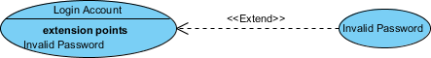 | An extension denotes that an extending action may be performed while an extended action is being  performed.

Generalization |  | This shows that an actor or a use case is a kind of another abstract or concrete actors which can be defined and later specialized using  generalization relationship.
System |  | It is a container of use cases which  interact with external actors

ACTORS OF OUR SYSTEM
- Primary Actors
Table 12 Actors of our system
Actor | Role
Patient | The primary user of the app, a patient actively manages their health by submitting daily health statuses, requesting expert consultations, performing crisis self-help procedures, and making secure payments for consultations via the Payment API. They also receive automated reminders for medication, hydration, or appointments and provide feedback on consultations.
Health Expert | Health experts deliver medical support by reviewing patient health status submissions, responding to consultation requests via chat or video calls, providing personalized health recommendations, and updating crisis management protocols. They manage their profiles to ensure accurate credentials and availability for patient interactions.
Administrator | Admins ensure platform efficiency by registering and approving health experts, managing patient accounts (e.g., activating or deactivating), publishing and validating health tips, monitoring consultation records, tracking payments processed through the Payment API, and generating platform usage reports.

- Secondary actors
Table 13 Secondary Actors of drepadata
Actor | Role
Payment API | This external system processes financial transactions by validating payment information, executing secure payments for patient consultations, and sending confirmation receipts to the app, enabling seamless and secure consultation bookings.
Chatbot API | This external system provides an interactive, conversational assistant within the app. It helps families quickly access information about sickle cell disease, genotype compatibility, and preventive measures without needing to search through multiple sections.

GENERAL USE CASE DIAGRAM
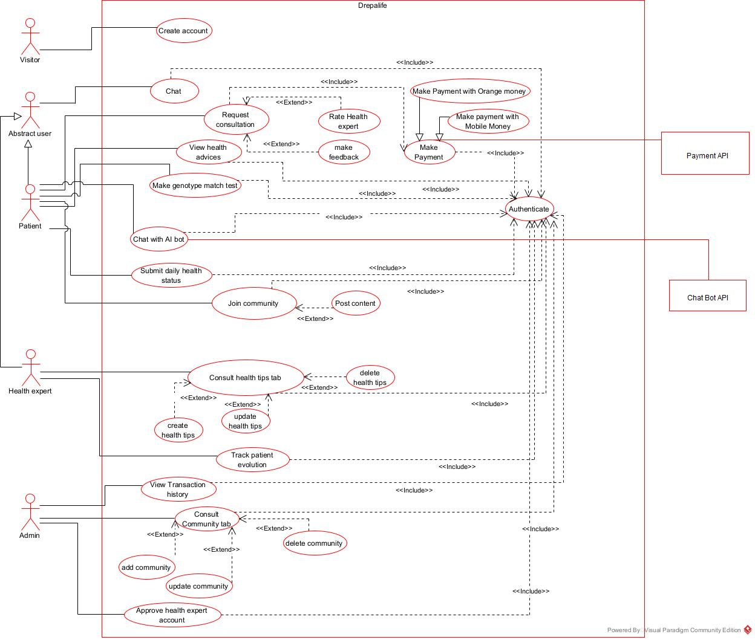
Figure 7 General Usecase of Drepalife

SPECIFIC USE CASE DIAGRAM FOR MAKE GENOTYPE MATCH TEST
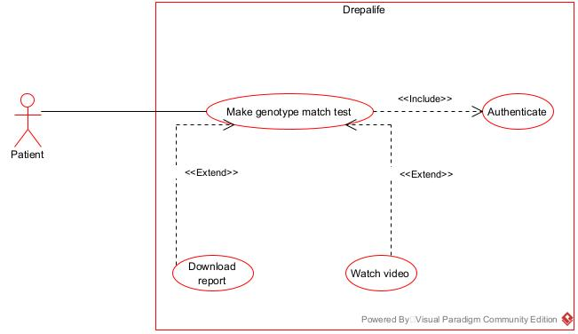
Figure 8 specific diagram for make genotype compatibility match test

TEXTUAL DESCRIPTION OF USE CASES
- Authenticate
Table 14 textual description of usecase
USECASE AUTHENTICATE
Summary | Permit Patient to access the system
Actors | Patient, Health Expert
Pre-condition(s) | - The actor already has an account;  - The app is launched  - The account must be active
Trigger | The user clicks on login button
Nominal scenario | - The user clicks on login button  - The system displays the login page  - The user fills form and submit  - The system checks conformity  - The system sends validation query  - The system treats the result returned by the database  - The user is directed to his page
Alternative scenario | - 8. If step 4 of the nominal scenario the format is not correct, an error message is returned to the user and he returns to step 3 of the nominal scenario.  - 9. If step 6 of the nominal scenario no user was found, the system  returns an error message and returns to step 3 of the nominal scenario
Post-condition of  Success | The user logs in successfully
Post condition of failure | An error message is display and user does not have access his  space.

- Make payment
Table 15 Textual description of make payment
Actions | Patient
Summary |  | Permit patients to pay for requesting a consultation
Actors |  | Patient, Payment API
Pre-condition(s) |  | - The app is launched  - The patient has successfully requested a consultation  - The Health expert has confirmed the Request
Trigger |  | The user clicks on payment button
Nominal scenario |  | - The user clicks on payment button  - The system displays payment form  - The patient fills form and submit  - The system checks conformity  - The system sends payment request  - The system treats the result returned by the payment API  - The system sends payment information to the database  - The system treats the result returned by the database  - The system displays a successful message
Alternative scenario |  | - If step 6 of the nominal scenario the format is not correct, an  error message is returned to the patient and he returns to step 2 of the nominal scenario.

- 13. If step 8 of the nominal scenario an error is found, an error message is returned to the patient and he returns to step 2 of the nominal scenario
- 14. If step 10 of the nominal scenario an error is found, an error message is returned to the patient and he returns to step 2 of the nominal scenario
Post-condition of success | - If successful, the patient receives a successful message.  - The system keeps a record of the payment transaction.
Post condition of failure | An error message is displayed

- Make Genotype Compatibility Match Test
Table 16 Textual description for genotype compatibility match test
Actions | Patient
Summary
  Permit patients to perform a genotype compatibility test by
  submitting genotype information and receiving test results.
Actors |  | Patient
Pre-condition(s) |  | - The app is launched  - The patient has been authenticated (logged in)  - The patient has access to genotype test functionality
Trigger |  | - The patient clicks on the “Genotype Test” button
Nominal scenario |  | - The patient clicks on the “Genotype Test” button  - The system displays the genotype test form  - The patient fills in and submits the genotype test form  - The system checks if the submitted data is valid  - If valid, the system displays a success message  - The system sends a genotype fetch query to the DBMS  - The DBMS executes the query and sends a response  - The system verifies the response  - If the response is correct, the system displays the genotype test result
Alternative scenario |  | - If in step 4 the data is invalid, the system displays an error message and returns to step 2.  - If in step 8 the response from the DBMS is invalid, the system displays an error message and stops the process.

COMMUNICATION DIAGRAM

DEFINITION
The communication diagram is used to model the specific interaction between the participants of the system. It describes both the static and dynamic behavior of the system. It shows the chronological succession of the actions performed by an actor to realize an operation.

FORMALISM
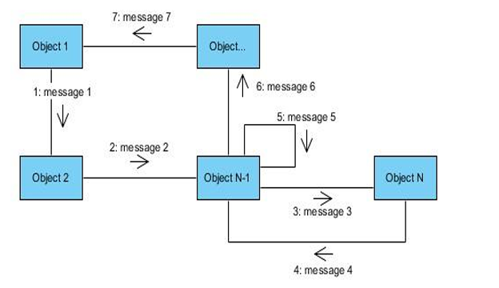
Figure 9 Formalism of communication diagram

COMPONENTS OF COMMUNICATION DIAGRAM
Table 17 Components of communication diagram
Element | Notation | Description
Message | 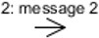 | Designs a particular  communication between lifelines.
Actors | 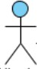 | A role play by an entity that interacts with the subjects
Link |  | It initiates an association it  connects two objects together for them to communicate.
Object | 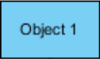 | An actor represents an  individual participant in the interaction conversation

AUTHENTICATE COMMUNICATION DIAGRAM
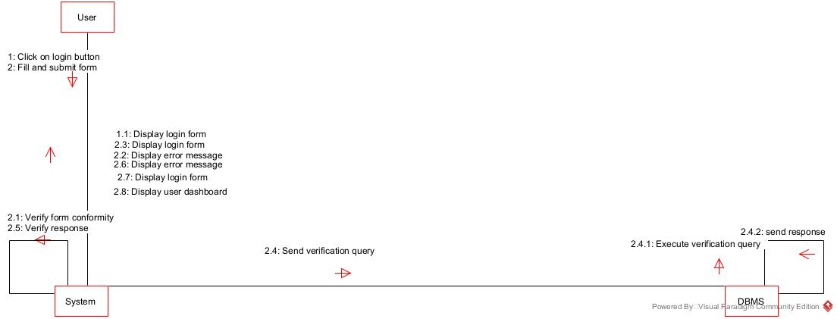
Figure 10 Authenticate communication diagram

MAKE GENOTYPE TEST MATCH COMMUNICATION DIAGRAM
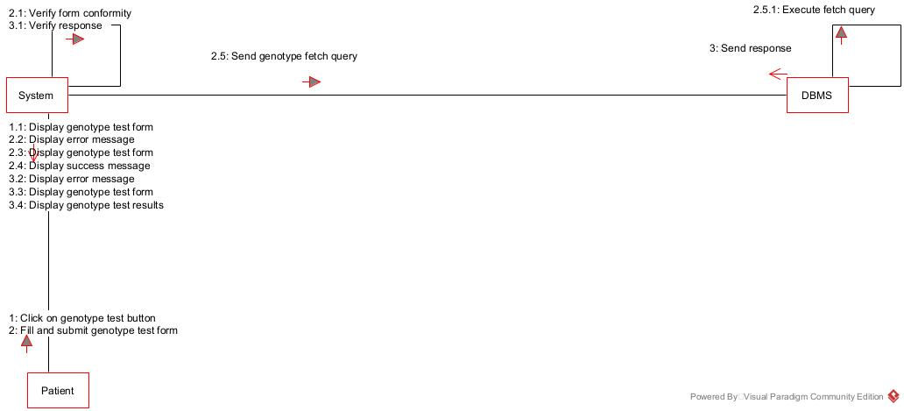
Figure 11 make genotype test match communication diagram

MAKE PAYMENT COMMUNICATION DIAGRAM
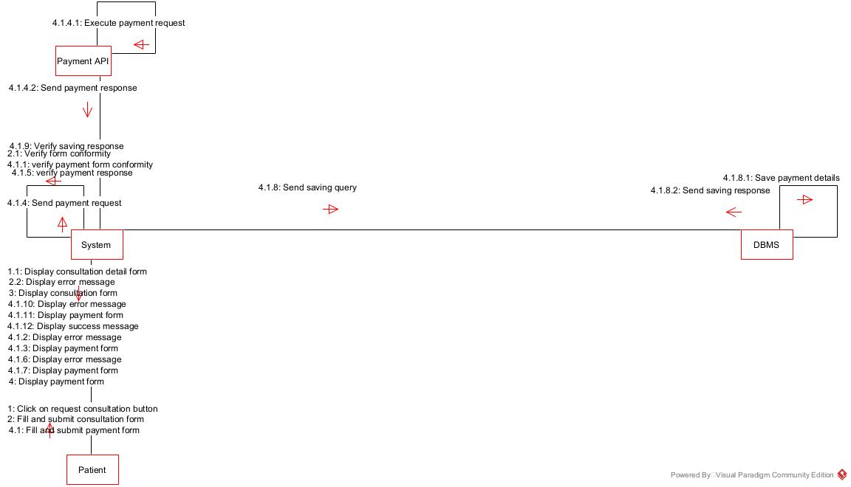
Figure 12 make payment communication diagram

SEQUENCE DIAGRAM

DEFINITION
A sequence diagram is a UML diagram that illustrates the sequence of messages between objects in an interaction. It consists of a group of objects that are presented by lifelines and the messages that they exchange over time during the interaction. These interactions are arranged from top to bottom following their order of occurrence.

FORMALISM
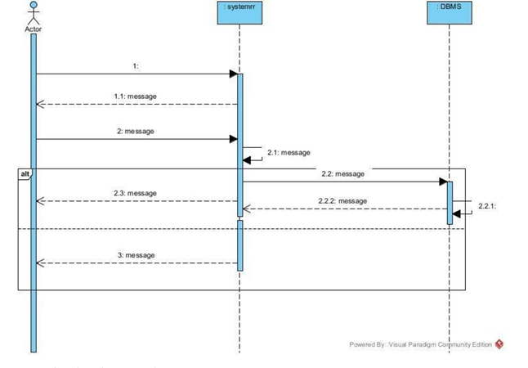
Figure 13 Formalism of sequence diagram

COMPONENTS OF SEQUENCE DIAGRAM
Table 18 Components of sequence diagram
Element | Notation | Description
Lifelines | 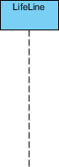 | They represent rows or objects instances that participate in the sequence  being modelled.
Asynchronous Message | 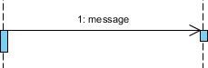 | It is a message that receives an indirect  response.
Synchronous Message |  | It is a message that sends  and want response before it continues a process
Self-Message | 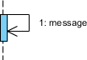 | Self message is a kind of message that represents the invocation of message of  the same lifeline.
Return Message | 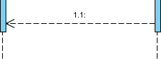 | It represents the response  of a message.
Actor |  | They send and  receive message.
Combined Interaction Fragment | 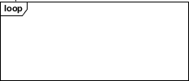 | An articulation of interaction diagram, defined by an operator and  operands.
Object |  | They send and receive messages

AUTHENTICATE SEQUENCE DIAGRAM
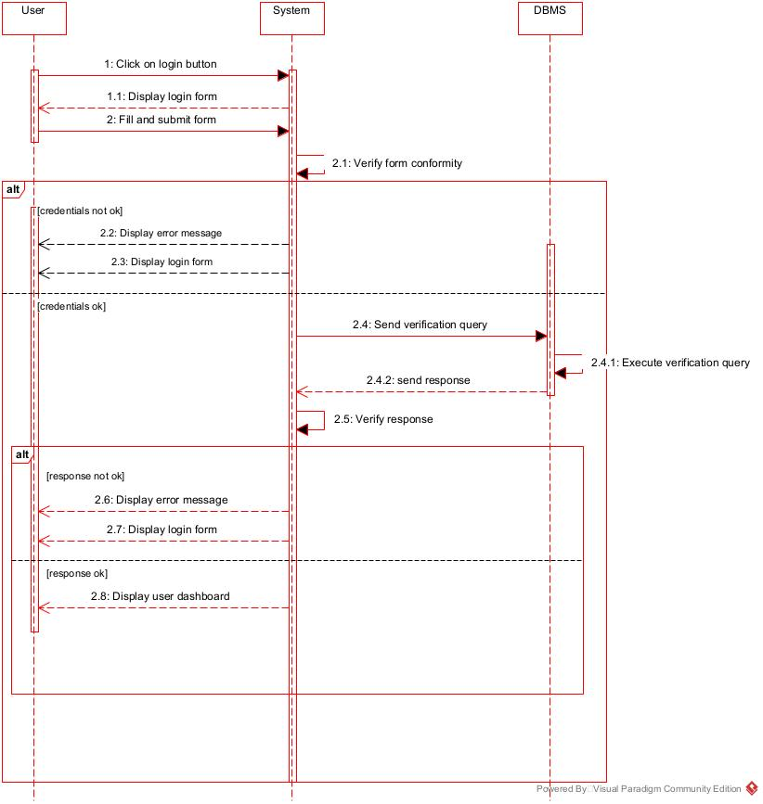
Figure 14 Authentication sequence diagram

MAKE PAYMENT SEQUENCE DIAGRAM
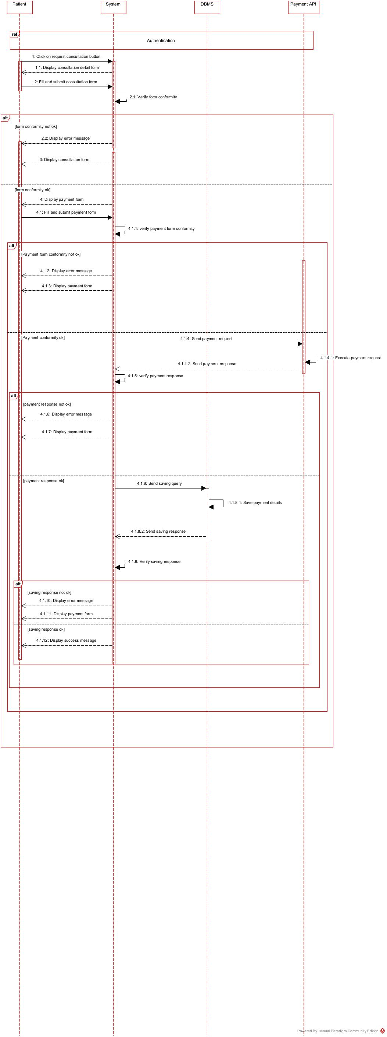
Figure 15 make payment sequence diagram

MAKE GENOTYPE TEST MATCH SEQUENCE DIAGRAM

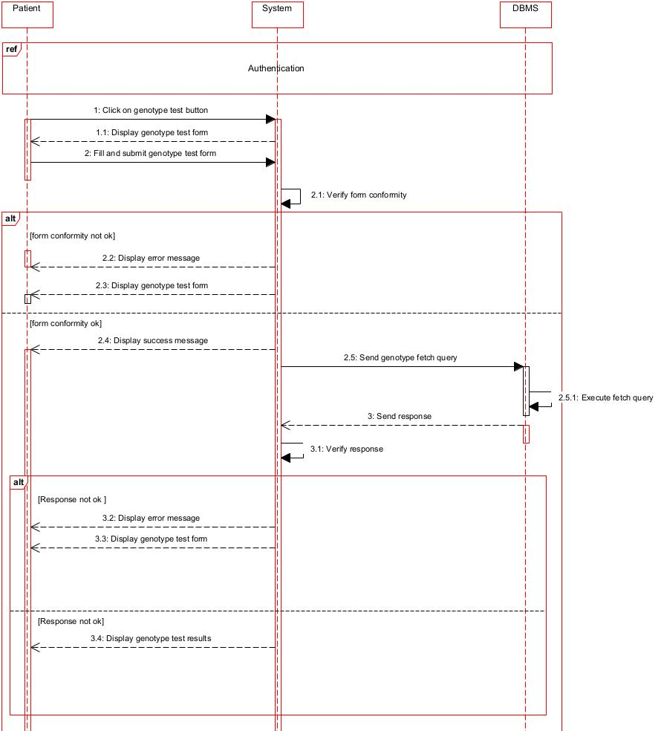
Figure 16 make genotype test match sequence diagram

ACTIVITY DIAGRAM

DEFINITION
An activity diagram is a graphical representation of workflows that show the steps needed in the realization of a process, showing the details from a start point to an end point through all decisions and actions that can possibly be performed. Activity diagrams are intended to model both the computational and organizational processes. The flow can be sequential, branched, or concurrent. Below is an activity diagram formalism.

FORMALISM
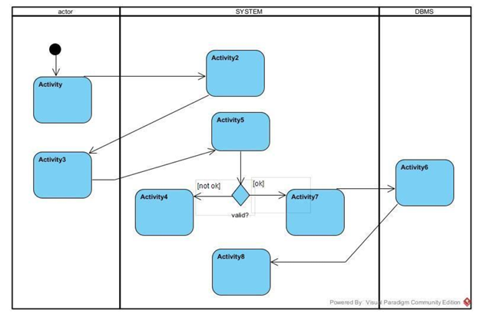
Figure 17 Formalism of activity diagram

COMPONENTS OF ACTIVITY DIAGRAM
Table 19 Components of activity diagram
Element | Notation | Description
Activity | 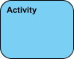 | Is used to represent a set of actions
Action | 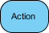 | A task to be performed
Activity Edge |  | An activity edge in a UML activity diagram is a directed connection between two activity nodes. It represents the flow of control or data  between these nodes.
Initial node |  | Portrays the beginning of a  set of actions or activities
Activity Final Node |  | Stop all control flows and object flows in an activity (or  action)
Object node | 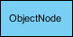 | Represent an object that is connected to a set of Object  Flows
Decision node | 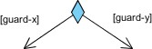 | Represent a test condition to ensure that the control flow or object flow only goes  down one path

Merge node | 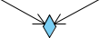 | Bring back together different decision paths that were created using a decision-  node.
Fork node | 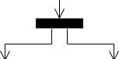 | Split behavior into a set of parallel or concurrent flows of activities (or actions)
Join node | 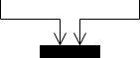 | Bring back together a set of parallel or concurrent flows of activities (or actions).
Swimlane and Partition | 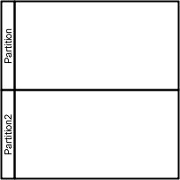 | A way to group activities performed by the same actor on an activity diagram or to group activities in a single thread

ACTIVITY DIAGRAM OF AUTHENTICATE
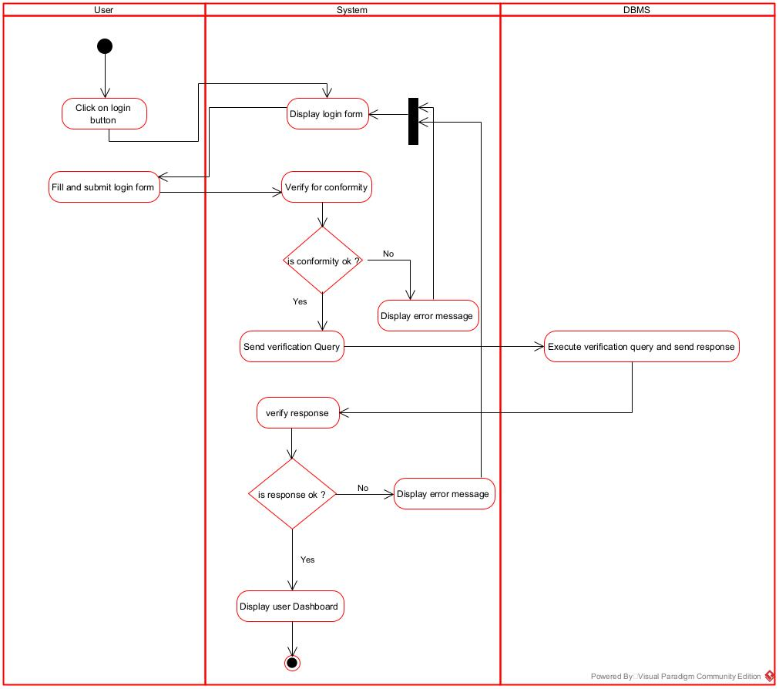
Figure 18 Authenticate activity diagram

MAKE GENOTYPE TEST MATCH ACTIVITY DIAGRAM
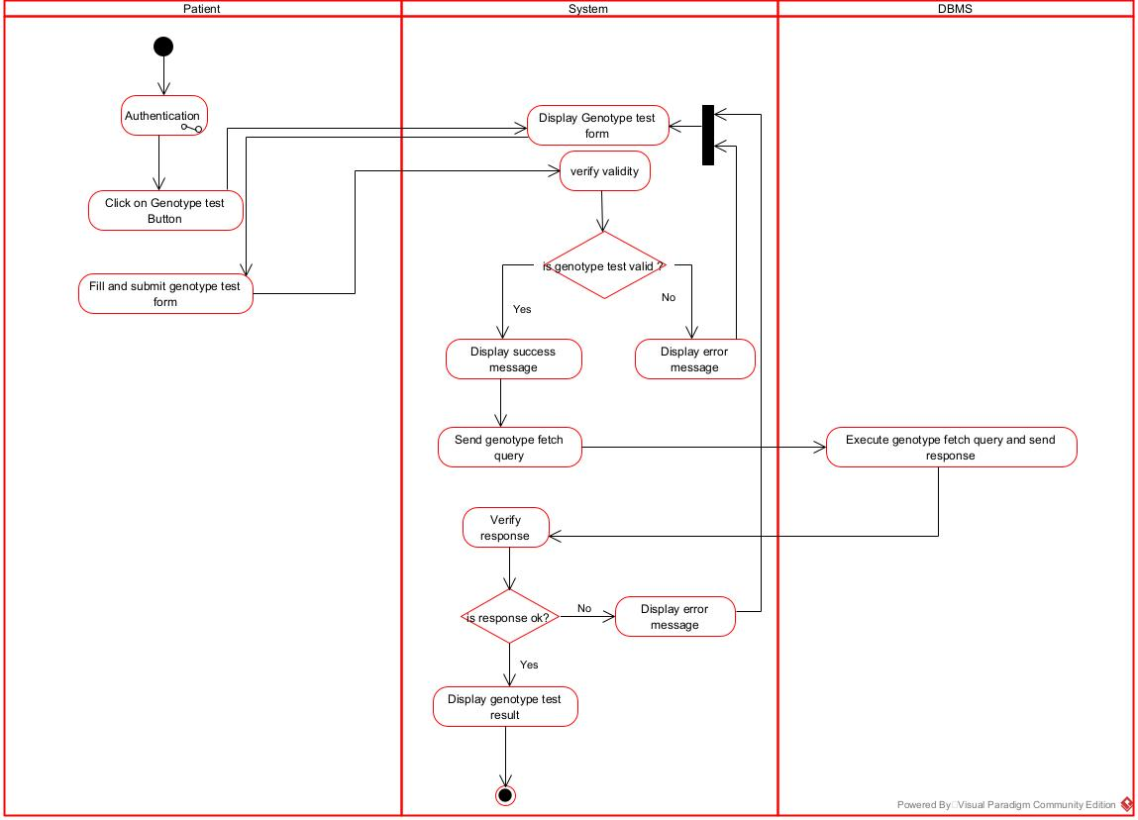
Figure 19 make genotype test match activity diagram

MAKE PAYMENT ACTIVITY DIAGRAM
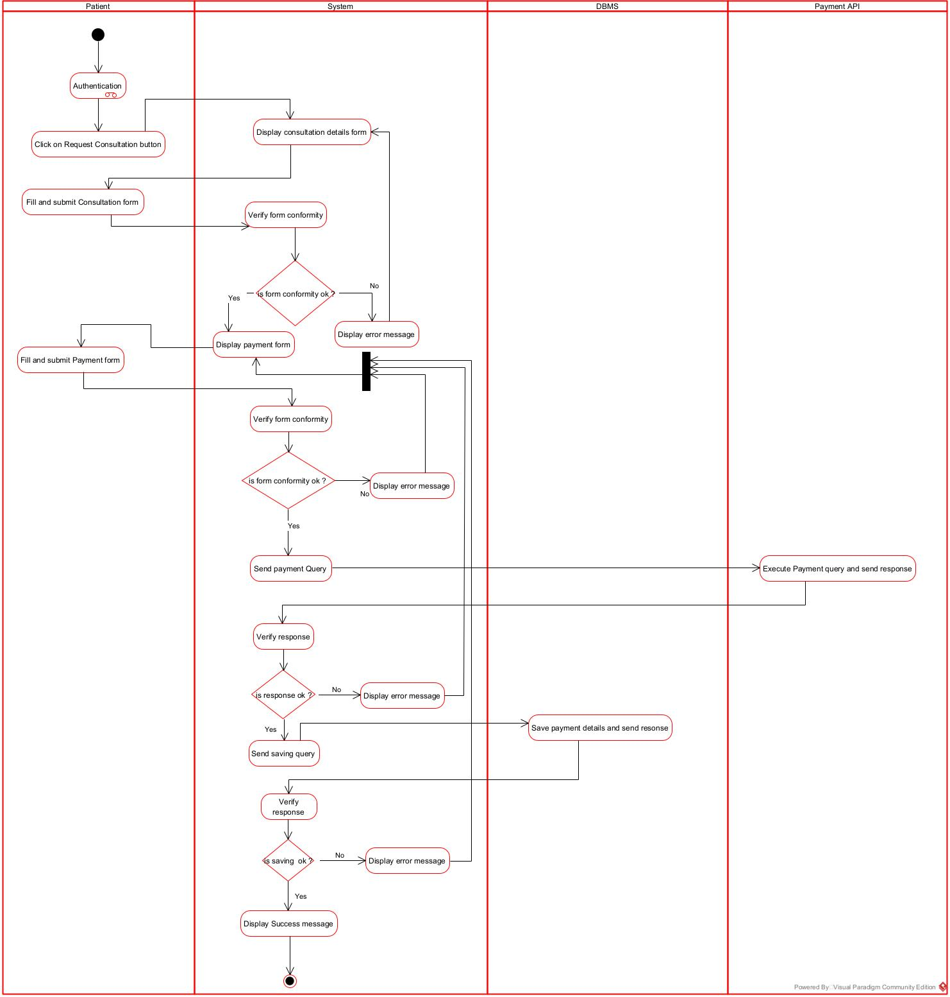
Figure 20 make payment activity diagram

CONCLUSION
Having reached the end of our analysis, we were asked to illustrate the language and method used during this phase, present the different diagrams of the functional branch. we can then say that this analysis file has allowed us delimit the functional needs of the web application that will be designed and to have a detailed overview of the new system to be set up without notwithstanding we quickly dive into the conception phase.

FILE 4 : CONCEPTION PHASE
Preamble
This document makes it possible to model the proposed solution as a whole and to gather the information necessary to set up a complex and efficient database. It therefore foresees the future system.

Content

INTRODUCTION
- CAPTURE OF TECHNICAL NEEDS
- CLASS DIAGRAM
- STATE MACHINE DIAGRAM
- PACKAGE DIAGRAM
CONCLUSION

INTRODUCTION
The realization of an analysis file is very important for the advancement of the application, it guarantees the reliability of maintenance and use of a software. That said, after analyzing our system, we will move on to the design of our future system. To do this we will follow the steps of the technical branch of the 2TUP process, making the diagrams associated with these steps namely the class diagram and the state machine diagram.

CAPTURE OF TECHNICAL NEEDS

PHYSICAL ARCHITECTURE
We implemented a three-tier architecture system.
The three-tier architecture is a client-server software architecture that consists of the user interface (presentation tier), business rules (logic tier), and data access/storage tier (data tier).
- Presentation tier: It is the user interface and communication layer of the application, where the end user interacts with the application. Its main purpose is to display information to and collect information from the user.
- Logic tier: The logic tier, also known as the application tier or middle tier, is the heart of the application. In this tier, information collected in the presentation tier is processed sometimes against other information in the data tier using business logic, a specific set of business rules. The logic tier can also add, delete or modify data in the data tier.
- Data tier: The data tier, sometimes called database tier, data access tier or backend, is where the information processed by the application is stored and managed. This can be a relational database management system such as PostgreSQL, MySQL, MariaDB, Oracle, DB2, Informix or Microsoft SQL Server, or in a NoSQL Database server such as Cassandra, CouchDB or MongoDB. In a three-tier application, all communication goes through the logic tier. The presentation tier and the data tier cannot communicate directly with one another.

LOGICAL ARCHITECTURE
The logical architecture of an application refers to the structural design that gives as much detail as possible without defining the system technology or environment. The architecture we have chosen for our application is the Model-View- Controller (MVC). The MVC architecture divides an interactive application into 3 components which are:
The model: this component corresponds to all the data-related logic of the application. It directly manages the data, logic and rules of the application.
The view: It is used for all the UI logic of the application. It obtains its data from the model via the controller and each view has an association controller component.
The controller: it acts as an interface between Model and View components to process all the business logic and incoming requests, manipulate data using the Model component and interact with views to render final output. The MVC can be represented as follows:
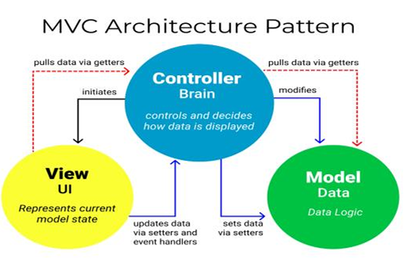
Figure 21 MVC architecture pattern

CLASS DIAGRAM

DEFINITION
A class diagram is a static diagram. It represents the static view of an application. class diagram is not only used for visualizing, describing, and documenting different aspects of the system, but also for constructing executable code of the software application. A class diagram describes the attributes and operations of a class and constraints imposed on the system. Its purpose is to model the static view of an application.

FORMALISM
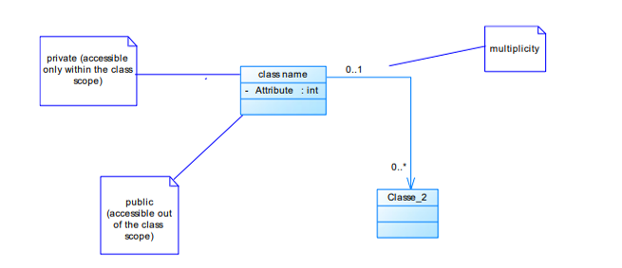
Figure 22 Formalism of a class diagram

COMPONENTS OF CLASS DIAGRAM
Table 20 Components of a class diagram
Element | Notation | Description
Class | 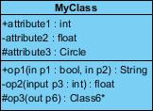 | A class is an element that defines the attributes and behaviours that an object can generate
Generalization | 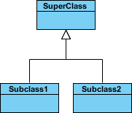 | it a relationship between a whole thing (called superclass) and a more specific thing (called subclass)
Association | 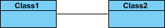 | It is a general type of relationship between elements, it may include  cardinality, roles etc.
Aggregation | 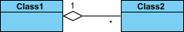 | If the parent of the aggregate is deleted, the  children are not deleted.
Composition | 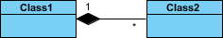 | If a parent of a composite is deleted all its parts are  deleted with it.
Dependency | 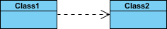 | It existed between two classes, if one changes it may cause the change in the order, but the other  way around

CLASS DIAGRAM OF DREPALIFE
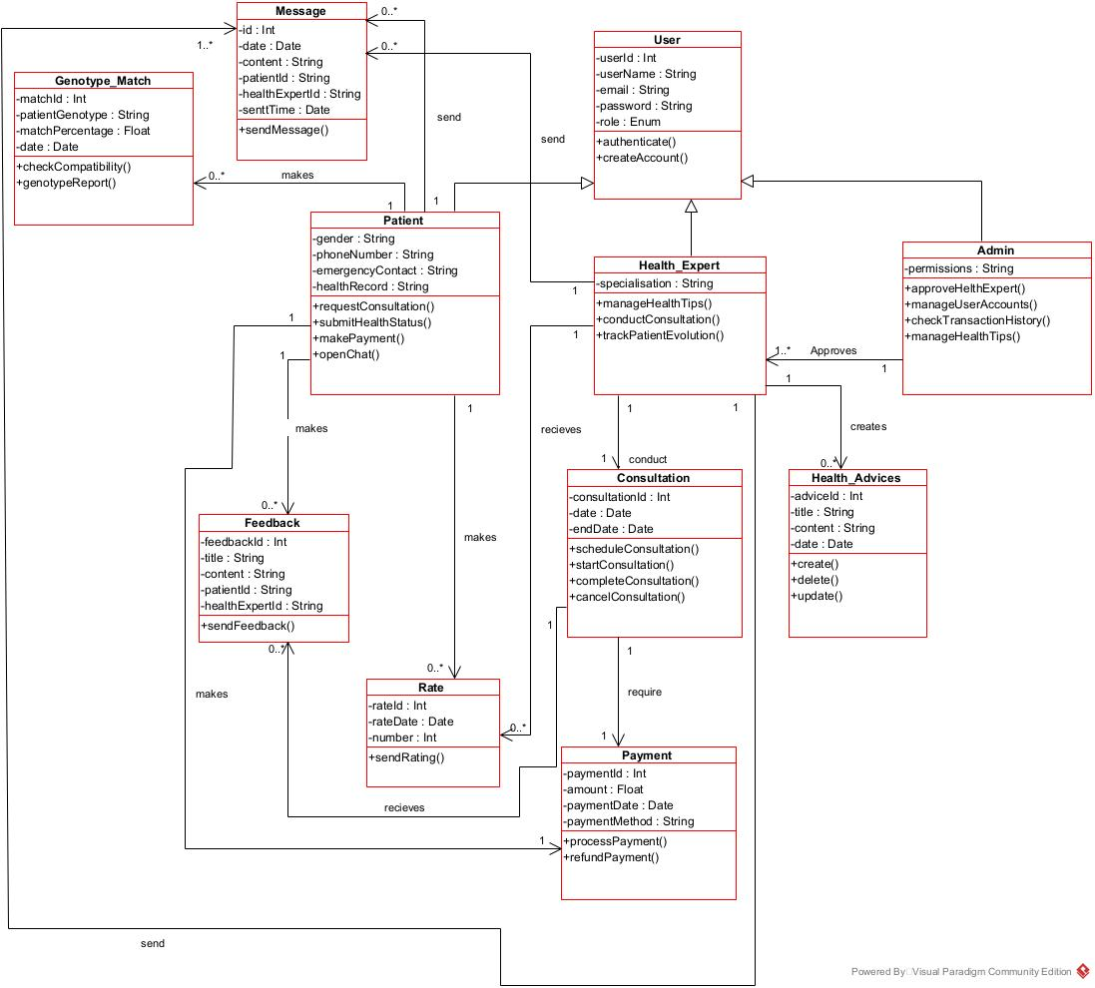
Figure 23 Drepalife Class Diagram

STATE MACHINE DIAGRAM

DEFINITION
A state machine diagram describes the behavior of a single object in response to a series of events in a system. Also known as the state machine diagram, it models the dynamic flow of control from the state of a particular object within a system.
.

FORMALISM
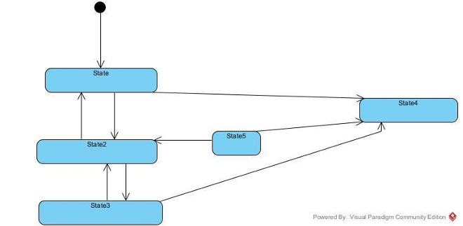
Figure 24 Formalism of state machine diagram

COMPONENTS OF STATE MACHINE DIAGRAM
Table 21 Components of a state machine diagram
Element | Notation | Description
State | 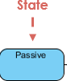 | Models a situation during which a certain invariant condition holds.
First (Initial State) |  | It represents a default vertex, that is, a source for a single transaction to the  default or composite state.
Final state |  | A state specifying that the enclosing region is  complete
Transition | 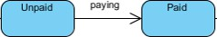 | A direction relation between a source and a  target vertex.
Choice pseudo state |  | A diamond symbol that indicates a dynamic condition with branched  potential results
Terminate |  | Implies that the execution  of a state by means of it context is terminated.

ACCOUNT STATE MACHINE DIAGRAM
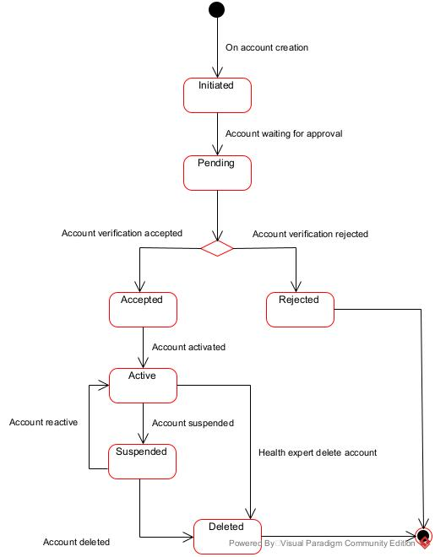
Figure 25 Account state machine diagram

PACKAGE DIAGRAM

DEFINITION
A package diagram is a type of structural diagram in UML that represents the organization and dependencies of different packages within a system or software application. Package diagrams are useful for visualizing the overall structure and organization of a system, as well as understanding the dependencies and relationships between the different components.

FORMALISM
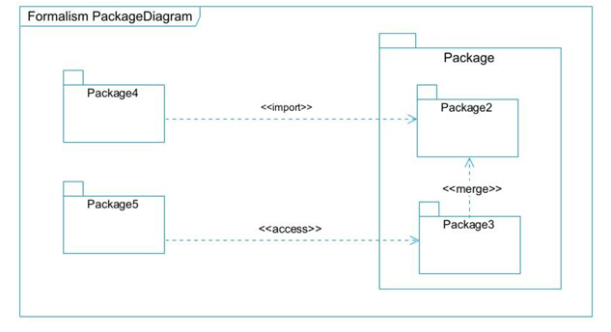
Figure 26 Formalism of package diagram

COMPONENTS OF PACKAGE DIAGRAM
Table 22 Components of a package diagram
Element | Notation | Description
Package | 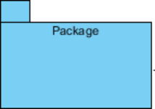 | A package is a namespace use to group related elements; it is a mechanism used to group elements into a better structure in a  system.
Package import | 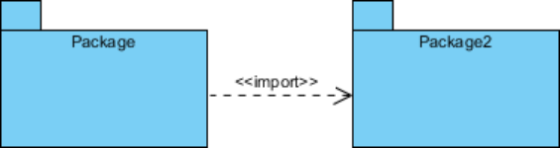 | A relationship Indicate that, functionality has been imported from one  package to another.
Package access | 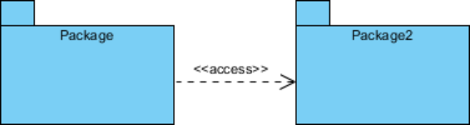 | A relationship Indicates that one package requires assistance from the function of  another package.
Package merge | 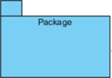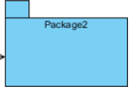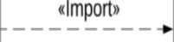 | It is a relationship which shows that, the functionality of two packages are combines  to a single function.

PACKAGE DIAGRAM OF DREPALIFE
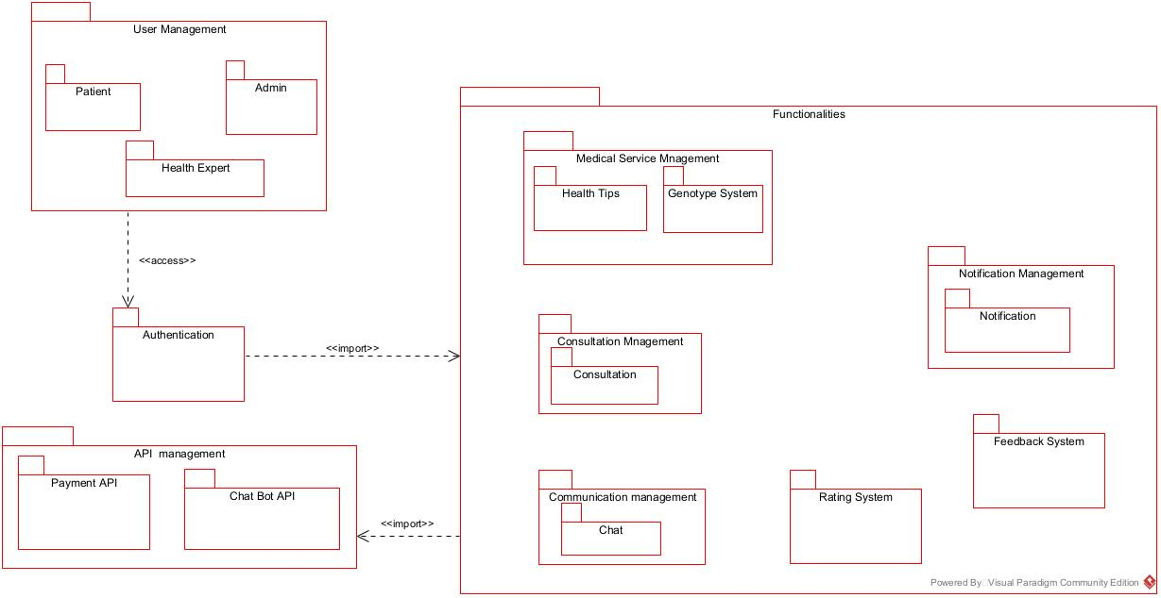
Figure 27 Drepalife package diagram

CONCLUSION
In the conception phase, we set as objective to plans the different aspects of our system by showing how it will be structured and deployed within existing technical architectures. We began by considering the technical constraints for our system, after which we proceeded to identify the components of our system, how they are grouped together and how they should be deployed on appropriate deployment targets. We finished this phase by looking at interactions between the various aspects and actors of our system. The next phase of our report is the realization phase where we will look at aspects concerning the implementation of our system.

FILE 5 : REALIZATION

Preamble
The realization document consists of the implementation of the project in a programming language according to the specifications defined in the previous file. It contains component and deployment diagrams, the testing and development phases. At the end of this part, programming documentation will be produced explaining the architecture of the database and the architecture of our code.

Content

INTRODUCTION
- DEPLOYEMENT DIAGRAM
- COMPONENT DIAGRAM
- TECHNICAL CHOICES
CONCLUSION

INTRODUCTION
Design and modeling are important links in the development process of an application because they make it possible to define and specify the different elements constituting the application or system studied. Realization is the culmination of the work carried out upstream because it makes it possible to physically create the various objects that were designed, and to bring the computer system to life. Throughout this phase, we will present the software, physical, and hardware architecture of our system through diagrams such as the component diagram, deployment diagram, physical model, and code architecture.

DEPLOYMENT DIAGRAM

DEFINITION
The deployment diagram models the hardware components used to implement a system and the association between those components. Deployment diagrams can be implemented as early as the design phase to document the system's physical architecture. As elements used in deployment diagrams, we can have, components, as in component diagrams, and nodes, which represent the physical processing resources of the system, and their associations.

FORMALISM
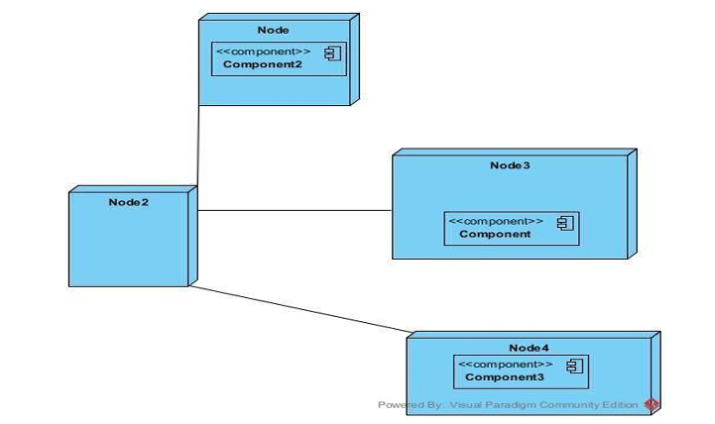
Figure 28 Formalism Deployment diagram

COMPONENTS OF DEPLOYMENT DIAGRAM
Table 23 Component of the deployment diagram
Element | Notation | Description
Node | 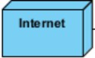 | A hardware or software  object, shown by a three-dimensional box
Artifact | 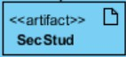 | An artifact is a major product, which is produced or used during the development of a software. E.g diagrams, data models, setup  scripts
Component | 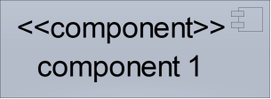 | It represents a modular part of a system that encapsulates its content and whose  manifestation is replaceable within it  environment.
Association | association | An association helps to connect two nodes together which permits them to communicate  together

DEPLOYMENT DIAGRAM OF DREPALIFE
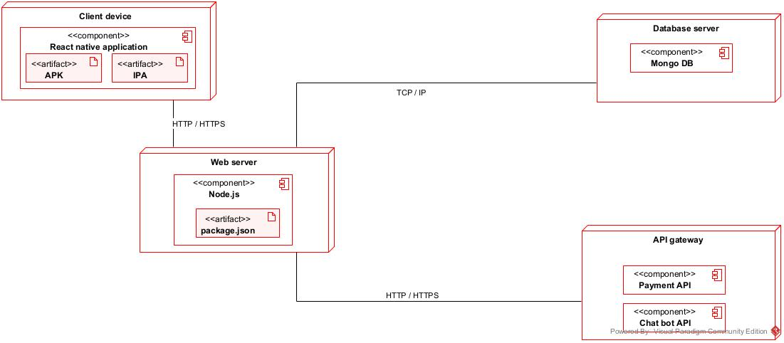
Figure 29 Drepalife Deployment diagram

COMPONENT DIAGRAM

DEFINITION
Component diagrams are used to model the physical aspect of a system. Now the question is, what is this physical aspect? They are elements such as Executables, libraries, files, documents, etc., which reside in a node. The component diagram does not describe the functionality of the system, but it describes the components used to make those functionalities.

FORMALISM
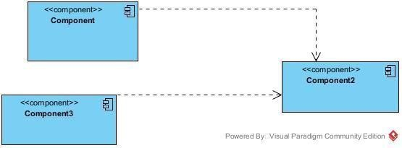
Figure 30 Formalism of Component diagram

COMPONENTS OF COMPONENT DIAGRAM
Table 24 Components of component diagram
Element | Notation | Description
Dependency |  | A dependency is a relationship that signifies that a single or a set of model elements requires other model elements for their specification or  implementation.
Port |  | A port is often used to help  expose required and provided interfaces of a component.
Interface | 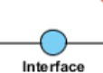 | It is a point of interaction between a component and its environment or other components. It specifies the services that a component provides or requires from  other components
Component | 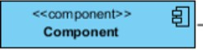 | It represents a self-contained and replaceable unit that interacts with other components via provided and  required interfaces

COMPONENT DIAGRAM OF DREPALIFE
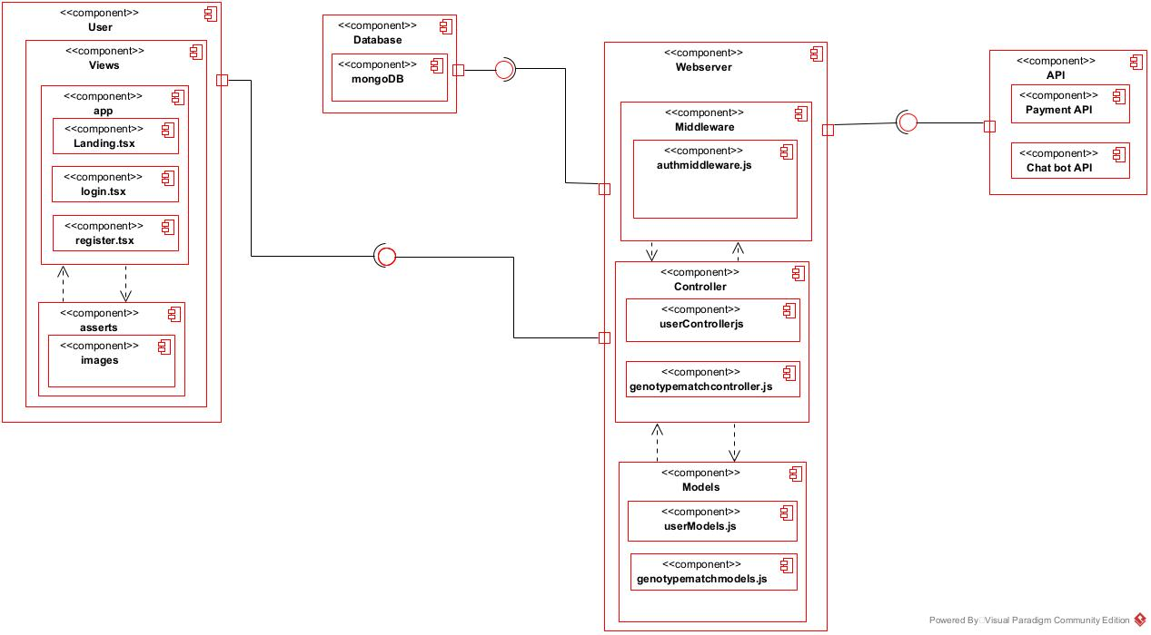
Figure 31 Drepalife Component diagram

TECHNICAL CHOICES
To set up our platform and meet the needs of the end-users, the technologies chosen are React Native for the front-end, combined with Node.js for the back-end, and MongoDB for interaction with the database. Each of these technologies will be presented in detail in the following paragraphs.
  - React Native;
React Native is an open-source framework. It allows developers to build mobile applications using JavaScript. In software development, a framework serves as a platform for developing applications. It contains resources like pre-built components, libraries, and reference material. It enables the creation of cross-platform apps that can run on both iOS and Android using a single codebase, which saves development time and effort.

Figure 32 React native logo

  - Node js;

Node.js is an open-source, cross-platform JavaScript runtime environment that allows developers to run JavaScript code on the server side. It uses Chrome's V8 JavaScript engine to execute code and is designed to build scalable and high-performance applications, especially for web services and APIs.

Figure 33 node js logo
  - MongoDB;

MongoDB is an open source, cross-platform, document-oriented database program. Classified as a NoSQL database product, MongoDB utilizes JSON-like documents with optional schemas. MongoDB is developed by MongoDB Inc.
Figure 34 mongoDB logo

  - Gantt Project;
Project Gant is a widely used project management tool for planning and tracking project tasks over a given period. A Gantt chart is particularly useful for visualizing dependencies between tasks, start and finish dates, and project progress.

Figure 35 Gantt Project
  - Visual paradigm;
Visual Paradigm Community Edition is a UML software that supports all UML diagram types. It is an international award-winning UML modeler, and yet it is easy-to-use, intuitive & completely free.

Figure 36 visual paradigm logo

  - Postman
Postman is a popular API development tool that facilitates the creation, testing and documentation of APIs. It is widely used by developers, testers and API development teams to simplify the process of working with HTTP APIs.

Figure 37 postman logo

CONCLUSION
During our realization phase, we successfully developed and implemented our application. To achieve this, we utilized our analysis and conception phase. We also created deployment and component diagrams which illustrate the modules, files, and assets, as well as how different elements interact with each other within our system. Our next step is to move onto the functionalities testing phase, where we will assess the efficacy of the various modules present in our app for different users.

FILE 6 : FUNCTIONALITY TESTING

Preamble
This phase aims at testing the software or application to verify if the system is working as expected. It involves testing individual functionalities and capabilities of the software to ensure that they work correctly and meet the specified needs.

Content

INTRODUCTION
- APPLICATION FUNCTIONALITIES
- TEST
CONCLUSION

INTRODUNCTION
It is a systematic process that involves evaluating the functionality of a software application or system in different phases or stages of its development lifecycle. This testing approach ensures that each phase of the software development process is thoroughly tested for its intended functionalities and overall performance. Its main goal is to identify and rectify any defects and bugs during the process.

APPLICATION FUNCTIONALITIES
- Authentication
This functionality enables the users to have access to their workspace or dashboard. In case he/she does not have an account he/she will register.
- Genotype Compatibility Check
Users input their genotype with that of a partner to receive instant risk predictions for their future children.
- Consultation Booking & Payments Families can securely book and pay for consultations with verified providers through the app.
- Chatbot Assistance
A conversational assistant answers common questions, guides users through risk checks, and directs them to educational or medical support.
- Join Community
This functionality enables the patient to join communities for better knowledge of the sickness
- Account and Management
Admin is capable of creating, deleting, blocking, or suspending accounts

TEST

DEFINITION
Testing, in simple terms, involves verifying that your code functions correctly. It is important because it boosts your confidence in the code and ensures its reliability. There are different types of testing, including:
- Unit test: In a unit test, you are testing whether each function is working properly.
- Feature test: In a feature test, you are testing whether your routes, controllers, and database behave as expected.
- Manual testing: Here, you are manually testing your application.
- Alternative or Automated testing: Using online tools to test your code.

TESTS MADE IN THE SCOPE OF OUR PROJECT
For testing the functionality of DrepaLife, we used Jest, a powerful JavaScript testing framework that allows us to perform unit and integration tests on both frontend and backend components. Jest ensures that each module of the application behaves as expected, helping to catch errors early and maintain the reliability of the platform.
.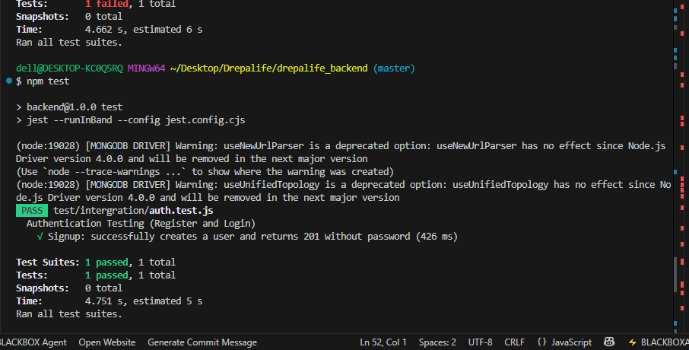
Figure 38 jest authentication test result

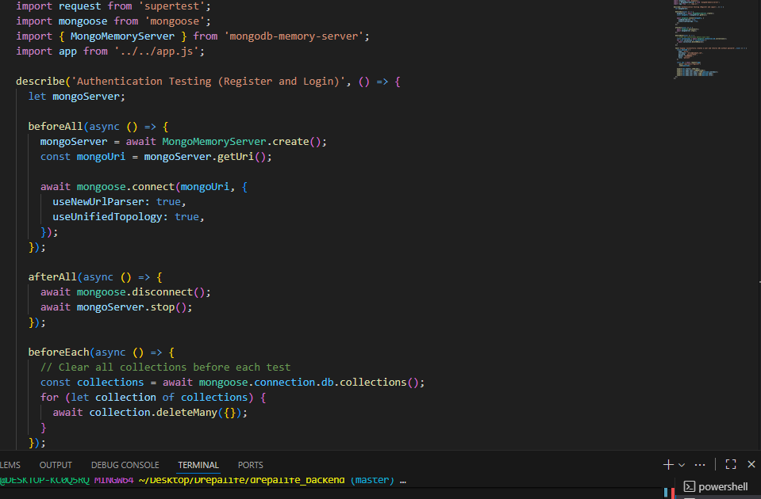
Figure 39 test code interface

CONCLUSION
Testing is an integral part of the software development life cycle and is performed to verify the correctness, reliability, and robustness of the implemented functionality. The functionality and testing phase is therefore a critical stage in software development where the implemented features are validated, and any issues are identified and resolved.

FILE 7 : USER GUIDE

Preamble
A user guide explains how to use a software application in a language that a non-technical person can understand. Thus, it enables the user to easily use the application to familiarize themselves with the software and discover all its functionalities.

Content

INTRODUCTION
- DESCRIPTION OF THE APPLICATION
- USER MANUAL
CONCLUSION

INTRODUCTION
The user manual is the document established after the realization of an application, software, or platform. It informs on the question "how to use the software, the application, or the platform that you have in front of you? ". It is therefore crucial for us to offer the various users of our platform a guide allowing them to easily perform various operations on our platform.

DESCRIPTION OF THE APPLICATION
Drepalife is a mobile health application designed to raise awareness and reduce early deaths caused by sickle cell disease in Cameroon. It helps families and individuals understand their genotype compatibility, assess sickle cell risks, and access reliable educational resources. The application also connects users to verified healthcare providers and offers a chatbot assistant for quick guidance.
Key features include:
- User Registration and Authentication: Create an account, log in, or use the app without authentication.
- Role Selection: Identify as a patient or healthcare provider to access tailored features.
- Genotype Compatibility Test: Check and understand genotype risks for children.
- Chatbot Assistant: Ask questions, get instant answers, and receive step-by-step guidance.
- Educational Materials: Access simplified guides and tips on sickle cell prevention and management.
- Healthcare Provider Access: View verified testing centers, clinics, and doctors for consultation.
- Event and Awareness Updates: Stay informed on campaigns, events, or initiatives related to sickle cell awareness.

USER MANUAL

PREREQUISITES
Before using Drepalife, ensure you have:
- An Android smartphone.
- The Drepalife APK file downloaded.
- A stable internet connection (for real-time features such as risk tests and chatbot).

USEFUL STEPS
Below are the steps you will follow to install and use the application:
- Download and Install
Download the Drepalife APK file.
Open it on your phone and follow the prompts to install.
- Launch the App
Tap the Drepalife icon to open the application.
- Landing Screen
Choose to create an account, log in, or continue without authentication.
- Sign Up
Enter your details (name, email, password, phone, emergency contact, role, gender).
- Log In
Use your email and password to access your account.
- Role Page
Select your role (e.g., Patient or Healthcare Provider) to access personalized features.
- Home Page
View events, announcements, and awareness updates.
- Genotype Test Page
Input genotypes to get instant compatibility and risk results.
- Chatbot Page
Interact with the chatbot to ask questions, receive guidance, or navigate the app.

SHOW CASE
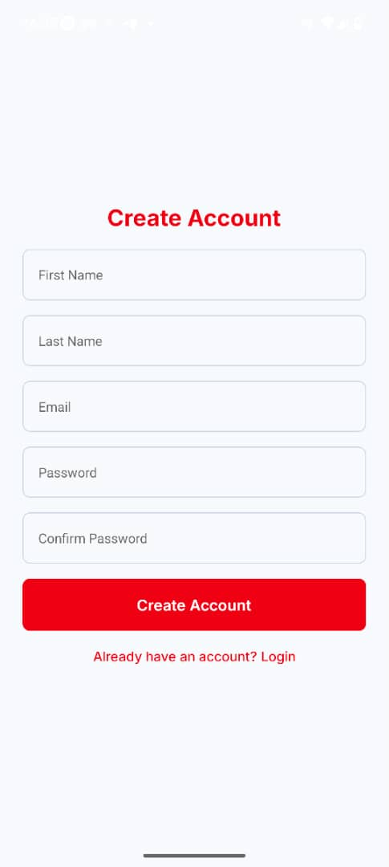
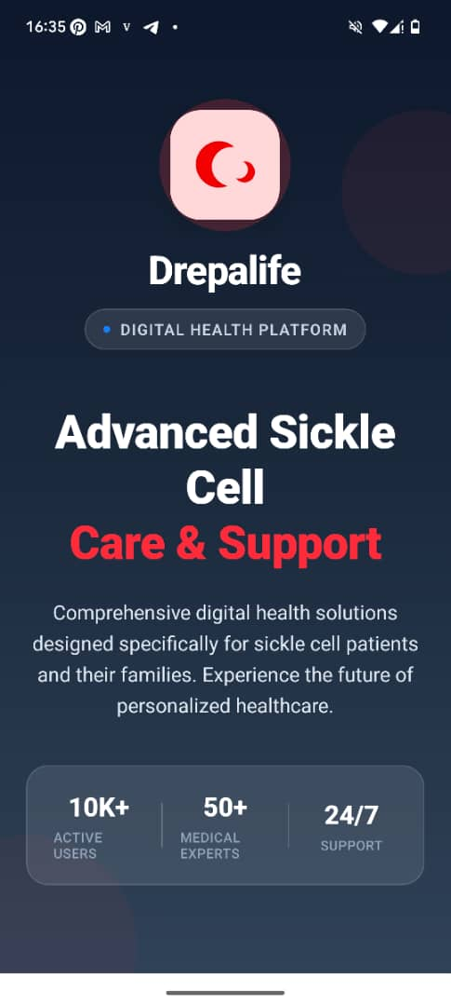
Figure 40 signup screen
Figure 41 landing screen
- Sign Up Screen: Register with personal and health details.

- Landing Screen: Create an account,
log in, or continue as a guest.

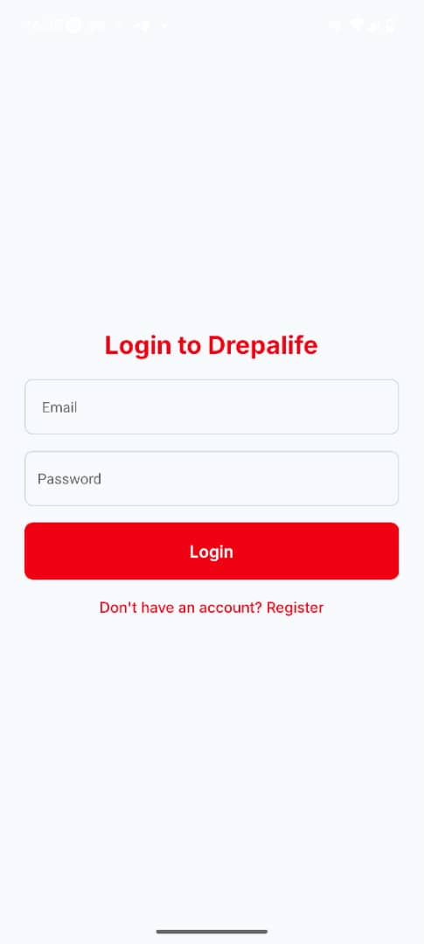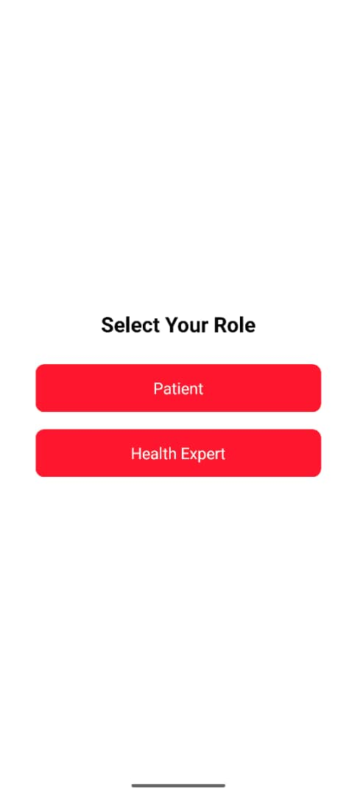
Figure 42 login screen
Figure 43 Role screen
- Log In :Use your email and password to access your account
- Role Page: Select user type for tailored experience.

- Patient dashboard
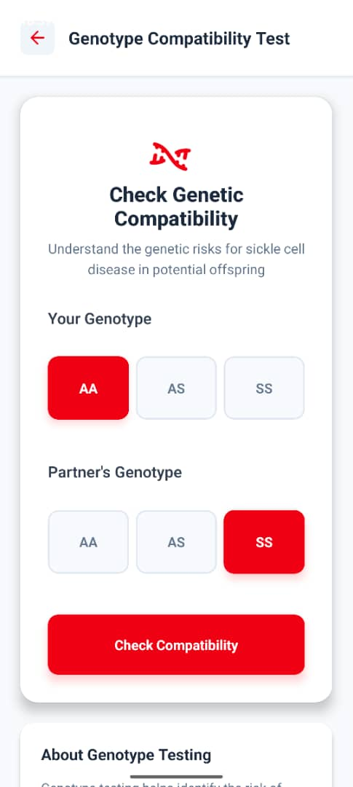
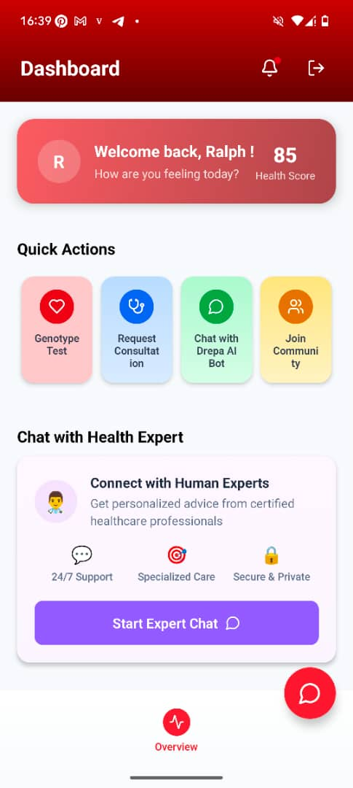
Figure 44 genotype test match screen
Figure 45 patient dashboard
- Genotype Test Page: Perform genotype compatibility check.

- Chatbot Page Access instant support and information.
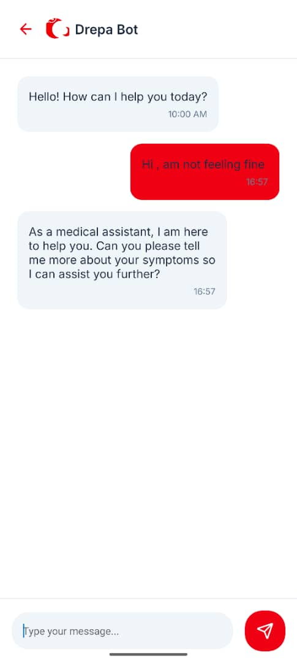
Figure 46 Drepa chatbot screen

CONCLUSION
This user guide has provided a comprehensive overview of our product's features, functionalities, and best practices for optimal use. By following the instructions and tips outlined in this document, you'll be well-equipped to maximize the potential of our product and streamline your workflow.

PERSPECTIVES

GENERAL CONCLUSIONPERSPECTIVES

Having developed the core functionalities of our application, we plan to improve it further with the following features:
- Integration of a secure payment system.
- User profile management for better personalization.
- Consultation and counseling services with health experts.
- A daily health guide and patient monitoring tools.
- Stronger security measures and provider verification.

GENERAL CONCLUSION

ANNEXESGENERAL CONCLUSION

Having come to the end of our project and our internship at REALIZE, we can proudly say that this experience has been both enriching and challenging. Throughout the three months, we were faced with moments of stress, failures, and successes, but each step helped us grow both professionally and personally. Our time at REALIZE was very beneficial as it allowed us to adapt to the professional environment, strengthen our teamwork spirit, and apply the knowledge acquired in class to real-world problems. For our project, we worked on the theme: “Conception and Realization of a Digital Health Support and Genotype Compatibility Platform for Sickle Cell Prevention in Cameroon.” Our greatest desire is to contribute to reducing the early death rate caused by sickle cell disease by equipping families with accessible tools for awareness, genotype risk assessment, and preventive guidance. The result of our work, Drepalife, will allow families to easily access genotype compatibility information, receive educational support, consult verified healthcare providers, and benefit from an integrated chatbot assistant for guidance. We will not stop here. In the near future, important updates and improvements will be made in terms of functionalities and security in order to make the system more reliable and impactful for communities across Cameroon and, hopefully, beyond.

ANNEXES

BIBLIOGRAPHYANNEXES

BIBLIOGRAPHY

WEBOGRAPHYBIBLIOGRAPHY

- Mercurial 2022 – 2025
- UML @ Classroom an introduction Object – Oriented Modelling, Gerti Kappel, Martina Seidl 2015.
- React Native for Mobile Development: Harness the Power of React Native to Create Stunning IOS and Android Applications 2nd edition Abhishek Nalwaya, 2019

WEBOGRAPHY

VIDEOGRAPHYWEBOGRAPHY

- https://www.geeksforgeeks.org/how-to-install-mongodb-on-windows/ Here we got the steps for installation of mongodb.
- https://stackoverflow.com/questions/78131028/country-picker-in-react-native Here we fine our country picker.
- https://www.meetup.com/about/ We got information about our existing system meetup.
- https://www.youtube.com/watch?v=TlB_eWDSMt4&list=PPSV We got a full course
- under node js.
- https://reactnative.dev/ we got here a course on how to use react native.
- https://expo.dev/go we got stips on how to install and use expo go for our project
- https://www.freecodecamp.org/news/the-model-view-controller-pattern-mvc-
- architecture-and-frameworks-explained/ Here we got the MVC diagram.

- https://www.mysciencework.com/omniscience/pervasive-mobile-healthcare-system- based here got the 2TUP diagram
- https://redux.js.org/tutorials/essentials/part-5-async-logic Async Logic and Data Fetching

VIDEOGRAPHY

TABLE OF CONTENTVIDEOGRAPHY

- https://youtu.be/0-S5a0eXPoc?si=abcdef How to set up a React Native project.
- https://youtu.be/3Eo_Fgz3rgQ?si=ghijkl Building your first mobile app with React Native
- https://youtu.be/0tKzqXz1V6s?si=mnopqr State management in React Native with Redux.
- https://youtu.be/kLJ2vD4T3xA?si=stuvwx Connecting React Native app to Node.js backend API.
- https://youtu.be/y9TnE4J7vFg?si=yzabcd Implementing authentication in React Native + Node.js.
- https://youtu.be/Oe421EPjeBE?si=efghij Node.js for beginners: Setting up server and routes
- https://youtu.be/fBNz5xF-Kx4?si=klmnop Express.js crash course for APIs.
- https://youtu.be/1NrHkjlWVhM?si=qrstuv Connecting MongoDB with Node.js
- https://youtu.be/pKd0Rpw7O48?si=cdefgh Building a RESTful API with Node.js + Express
- https://youtu.be/Kl8H3F5pWrA?si=abc890 Building AI-powered chat feature in React Native using OpenRouter API.

REFERENCES

GENERAL INTRODUCTIONGLOSSARY

Books
- Kappel, G., & Seidl, M. (2015). UML Classroom: An Introduction to Object-Oriented Modelling. Springer.
- Nalwaya, A. (2019). React Native for Mobile Development: Harness the Power of React Native to Create Stunning iOS and Android Applications
- Mercurial. (2022–2025). Mercurial Documentation.
Web Sources
- Expo. (n.d.). Getting started with Expo Go. Retrieved from https://expo.dev/go
- FreeCodeCamp. The Model-View-Controller pattern (MVC): Architecture and frameworks explained. Retrieved from https://www.freecodecamp.org/news/the-model-view-controller-pattern-mvc-architecture-and-frameworks-explained/
- GeeksforGeeks. How to install MongoDB on Windows. Retrieved from https://www.geeksforgeeks.org/how-to-install-mongodb-on-windows/
- Meetup About Meetup. Retrieved from https://www.meetup.com/about/
- MyScienceWork. Pervasive mobile healthcare system. Retrieved from https://www.mysciencework.com/omniscience/pervasive-mobile-healthcare-system-based
- React Native. React Native documentation. Retrieved from https://reactnative.dev/
- Redux. Async logic and data fetching. Retrieved from https://redux.js.org/tutorials/essentials/part-5-async-logic
- Stack Overflow. (2024). Country picker in React Native. Retrieved from https://stackoverflow.com/questions/78131028/country-picker-in-react-native
Videos
- FreeCodeCamp. Node.js full course YouTube. Retrieved from https://www.youtube.com/watch?v=TlB_eWDSMt4&list=PPSV
- Building a RESTful API with Node.js + Express YouTube. Retrieved from https://youtu.be/pKd0Rpw7O48?si=cdefgh
- Building AI-powered chat feature in React Native using OpenRouter API YouTube. Retrieved from https://youtu.be/Kl8H3F5pWrA?si=abc890
- Building your first mobile app with React Native. YouTube. Retrieved from https://youtu.be/3Eo_Fgz3rgQ?si=ghijkl
- Connecting MongoDB with Node.js YouTube. Retrieved from https://youtu.be/1NrHkjlWVhM?si=qrstuv
- Connecting React Native app to Node.js backend API YouTube. Retrieved from https://youtu.be/kLJ2vD4T3xA?si=stuvwx
- Express.js crash course for APIs YouTube. Retrieved from https://youtu.be/fBNz5xF-Kx4?si=klmnop
- Implementing authentication in React Native + Node.js YouTube. Retrieved from https://youtu.be/y9TnE4J7vFg?si=yzabcd
- Node.js for beginners: Setting up server and routes YouTube. Retrieved from https://youtu.be/Oe421EPjeBE?si=efghij
- How to set up a React Native project YouTube. Retrieved from https://youtu.be/0-S5a0eXPoc?si=abcdef
- State management in React Native with Redux YouTube. Retrieved from https://youtu.be/0tKzqXz1V6s?si=mnopqr

TABLE OF CONTENT

TABLE OF CONTENT

DEDICATION I
DEDICATION I
ACKNOWLEDGEMENTS II
SUMMARY III
LIST OF TABLES IV
LIST OF FIGURES V
GLOSSARY VII
ABSTRACT VIII
GENERAL INTRODUCTION 1
PART ONE: INSERTION PHASE 3
Preamble 4
Content: 4
INTRODUCTION 5
I. WELCOMING AND INTEGRATION 6
II. GENERAL PRESENTATION OF REALIZE 7
A. Administrative organization 8
B. FUNCTIONAL ORGANIZATION OF REALIZE 10
IV. HARDWARE AND SOFWARE RESOURCES 11
A. HARDWARE RESOURCES 11
B. SOFTWARE RESOURCES 11
CONCLUSION 13
PART TWO: TECHNICAL PHASE 14
FILE ONE: EXISTING SYSTEM 15
INTRODUCTION 17
I. PRESENTATION OF THE THEME 18
II. STUDY OF THE EXISTING SYSTEM 18
III. LIMITATIONS OF THE EXISTING SYSTEM 18
IV. PROBLEMATIC 20
V. PROPOSED SOLUTION 21
CONCLUSION 22
FILE 2: SPECIFICATION BOOK 23
INTRODUCTION 25
I. CONTEXT AND JUSTIFICATION 26
a. Context 26
b. Justification 26
II. OBJECTIVES OF THE PROJECT 27
A. GENERAL OBJECTIVE 27
III. EXPRESSION OF NEEDS 29
1. Functional Needs 29
2. Non-Functional Needs 30
IV. PROJECT PLANNING 32
a. Chronogram of activities 32
b. Gantt Project planning 34
V. ESTIMATED COST OF THE PROJECT 35
a. Software Resources 35
b. Hardware Resources 36
c. Human resources 36
d. Global Estimation 37
VI. LIST OF PARTICIPANTS 37
VII. PROJECT CONSTRAINTS 38
VIII. DELIVERABLES 39
CONCLUSION 40
FILE 3 : THE ANALYSIS PHASE 41
INTRODUCTION 43
I. METHODOLOGY 44
a. COMPARATIVE ANALYSIS BETWEEN MERISE AND UML 44
b. PRESENTATION OF THE 2TUP 46
c. CHARACTERISTICS OF 2TUP 48
d. JUSTIFICATION OF THE CHOICE OF THE ANALYSIS 49
II. MODELLING 49
a. USECASE DIAGRAM 49
b. COMMUNICATION DIAGRAM 59
c. SEQUENCE DIAGRAM 62
d. ACTIVITY DIAGRAM 67
CONCLUSION 73
FILE 4 : CONCEPTION PHASE 74
INTRODUCTION 76
I. CAPTURE OF TECHNICAL NEEDS 77
II. CLASS DIAGRAM 79
III. STATE MACHINE DIAGRAM 82
IV. PACKAGE DIAGRAM 85
CONCLUSION 88
FILE 5 : REALIZATION 89
INTRODUCTION 91
I. DEPLOYMENT DIAGRAM 92
II. COMPONENT DIAGRAM 95
III. TECHNICAL CHOICES 98
CONCLUSION 101
FILE 6 : FUNCTIONALITY TESTING 102
INTRODUNCTION 104
I. APPLICATION FUNCTIONALITIES 105
II. TEST 105
a. DEFINITION 105
b. TESTS MADE IN THE SCOPE OF OUR PROJECT 106
CONCLUSION 108
FILE 7 : USER GUIDE 109
INTRODUCTION 111
I. DESCRIPTION OF THE APPLICATION 112
II. USER MANUAL 113
➢ PREREQUISITES 113
➢ USEFUL STEPS 113
2. SHOW CASE 114
CONCLUSION 118
PERSPECTIVES 119
GENERAL CONCLUSIONPERSPECTIVES 119
GENERAL CONCLUSION 120
ANNEXESGENERAL CONCLUSION 120
ANNEXES XII
BIBLIOGRAPHYANNEXES XII
BIBLIOGRAPHY XIII
WEBOGRAPHYBIBLIOGRAPHY XIII
WEBOGRAPHY XIV
VIDEOGRAPHYWEBOGRAPHY XIV
VIDEOGRAPHY XV
TABLE OF CONTENTVIDEOGRAPHY XV
REFERENCES XVI
GENERAL INTRODUCTIONGLOSSARY XVI
TABLE OF CONTENT XVIII
TABLE OF CONTENT XVIII

